

**Collaboard CI/CD**

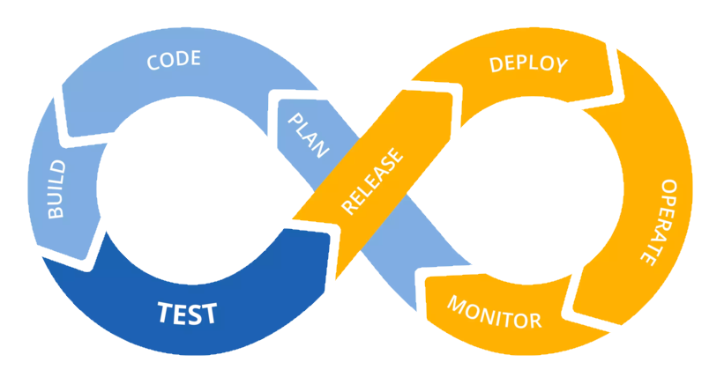DETAILED OVERVIEW

|  |  |
| --- | --- |
| Title: | Collaboard CI/CD detailed overview |
| Abstract: | This document details the specification for the security implemented in CollaBoard |
| Status* | Approved |
| Document Owner: | IBV |
| Document Author: | Gian Paolo Santopaolo |
| *Draft, In progress, Reviewed, Authorized, Approved, Completed | |

|  |  |  |
| --- | --- | --- |
| **Document Control** | | |
| Document Distribution: | Internal: | All dev Teams |
|  | External: |  |
| Document Authorization: | Authorizer(s): | Gian Paolo Santopaolo |

|  |  |  |  |
| --- | --- | --- | --- |
| **Change History** | | | |
| Date | Ver | Changed By | Details |
| 26/02/2018 | 1.0 | GP Santopaolo | Initial Draft |
| 27/02/2018 | 1.1 | GP Santopaolo | Added the Agile methodologies chapter |
| 28/02/2018 | 1.2 | GP Santopaolo | Work on the Agile process in Collaboard |
| 01/03/2018 | 1.2 | GP Santopaolo | Work on the Agile process in Collaboard |
| 09/07/2019 | 1.3 | GP Santopaolo | Added CI tools chapter |
| 10/07/2019 | 1.4 | GP Santopaolo | Added CI CD chapter |
| 11/07/2019 | 1.5 | GP Santopaolo | Added CI-CD security chapter |
| 12/07/2019 | 1.6 | GP Santopaolo | Added Continuous Deployment chapter |
| 13/07/2019 | 1.7 | GP Santopaolo | Added ending chapter |
| 12/03/2019 | 1.8 | GP Santopaolo | Revised whole document |
| 19/05/2021 | 1.9 | GP Santopaolo | Document Update and revision |

Index

Introduction 5

Purpose of the document 5

Background on Continuous Integration and Continuous Delivery/Deployment? 6

A bit of history 6

Agile methodologies and how to apply them to the project 8

Scrum 9

Test-Driven Development 10

eXtreme Programming (XP) 10

Pomodoro technique 10

Agile in CollaBoard project 11

Choosing the right process 11

Basic, Agile, Scrum, and CMMI 11

Main distinctions among the default processes 13

Workflow states, transitions, and reasons 14

The Agile process in CollaBoard 19

Plan and track work with Agile 19

Agile process work item types and workflow 20

Define user stories 20

Capture comments in the Discussion section 24

*Track progress* 24

Agile workflow states 25

Update status with Kanban or taskboards 25

Map user stories to features 26

Define tasks 26

Track test progress 28

Test user stories 28

Definitions for common WIT fields 30

Customize work item types 31

Track issues 31

*Track business value* 32

Backlog list order 32

Creating product backlog 33

Prerequisites 33

Backlog from the web portal 33

Determine if bugs should appear on your backlog 34

Convert ideas into backlog items or stories 35

Move items into priority order 35

Add details and estimates 36

Organizing the backlog, map child work items to parents 39

Prerequisites 39

Backlog from the web portal 39

Show parents and expand the tree hierarchy 39

Map items to group them under a feature or epic 41

Change parent (re-parent) and reorder items 42

Change parent of multiple backlog items 42

Add portfolio backlog levels and boards 43

Define, triage, and manage bugs 44

Prerequisites 44

Define and list bugs 44

Bug work item form 45

Fields specific to bugs 45

Capture comments in the Discussion section 47

Edit or delete a comment 48

Add a reaction to a comment 48

Triage bugs 49

Bug queries 49

Triage mode in query results 49

Assign bugs to a sprint 49

Fix, resolve and close bugs (update status) 49

Bug workflow lifecycle 49

Verify a fix 50

Verify a bug, re-run tests defined for web apps 50

Close a bug 51

Monitor bug status, assignments, and trends 51

Manage issues or impediments 53

*Prerequisites* 53

When to use issues versus tasks 53

Add an issue or impediment 53

Customize issues tracking 54

Azure DevOps Git workflows in CollaBoard 55

Git workflow 55

Create a branch 55

How are Git branches created? 56

Create a branch 56

Delete branch 57

Use branches to manage development 57

Commit changes 58

How Git tracks changes 58

What's in a commit 58

Stage your changes 59

Create a commit 59

Update your last commit 59

Push your branch 59

Resolve merge conflicts before pushing 60

Create a pull request 60

Create a pull request 60

Who reviews the pull request? 63

How does the code review work? 63

Complete a pull request 64

What happens when a pull request is merged? 65

Continuous Integration tools 66

Source Code Management 66

Azure DevOps 66

Quality Assurance 67

Visual Studio Code Analysis 67

OWASP Dependency-Check 67

Dependency Tracker 68

NuGet Dependency Checker 69

Automation Server 69

Azure DevOps Pipelinees 69

Artifact Repository 69

DevOps tools on Azure 69

Automated testing 70

Azure Pipeline testing tasks 70

Testing tools in Visual Studio 71

Continuous Integration Continuous Delivery in Collaboard 75

Architecture 75

Prerequisites 76

Sign in to the Azure portal 76

Configure access to your GitHub repo and choose a framework 76

Configure Azure DevOps and an Azure subscription 76

Commit changes to GitHub and automatically deploy them to Azure 77

Examine the Azure Pipelines CI/CD pipeline 77

Configure Azure Application Insights monitoring 78

Clean up resources 80

State of the art CI/CD in CollaBoard 81

CI/CD CollaBoard Server 81

CI/CD CollaBoard Server / Test environment 83

CI/CD CollaBoard Server / Release environment environment 86

CI/CD CollaBoard Server / On-premises environment 88

CI/CD CollaBoard Client 89

CI/CD CollaBoard Client On-Premises 91

CI/CD CollaBoard Client Test Environment 92

CI/CD CollaBoard Client Release Environment 93

Continuous security validation to CI/CD for Software Quality Assurance 94

IDE / Pull Request 95

Application Deployment to DEV and TEST 96

Continuous Deployment in Collaboard 99

Architecture 99

Getting started 99

Provision infrastructure via ARM template 100

Define service connections 100

Trigger and variable definition 100

Define your CI pipeline 101

Define your CD pipeline 102

Environments 103

Azure unified monitoring solution 104

Conclusions and next steps 105

Abbreviations and acronyms 106

# Introduction

Enterprises today face the challenge of rapidly changing competitive landscapes, evolving security requirements, and performance scalability.

Enterprises must bridge the gap between operations stability and rapid feature development. Continuous integration and continuous delivery (CI/CD) is a practice that enables rapid software changes while maintaining system stability

and security.

## Purpose of the document

This document shows the tools and methodologies to be applied during the project lifetime in order to provide an efficient Continuous Integration and testing software engineering approach (CI), trying to set the steps for the

continuous delivery or deployment (CD). This deliverable is mainly focused on the technical people in the project although part of the methodologies can be shared also with non-technical experts.

The research done to select the appropriated tools has been disregarded from the following document. The more widespread and well-known CI/CD are used. The description and configuration of these tools are given in order to replicate the environment. Nevertheless, the most remarkable results of the task are the workflows and guidelines given to the developers. From pasts experiences, the implantation of CI/CD tools lacking from a thorough branching workflow in the source code management system guides to the misuse or even withdrawal of them, and we want to avoid this in the CollaBoard project.

Deliverable aims not only to describe the tools integrated to be used, but also to share a set of good practices to foster the cultural change needed to spread this collaboration techniques throughout the group.

Together with this environment to facilitate an efficient development in CollaBoard, a collaborative wiki will be maintained in order to share the knowledge online.

# Background on Continuous Integration and Continuous Delivery/Deployment?

This section discusses the practices of continuous integration and continuous

delivery. We explain the difference between continuous delivery and continuous

deployment. Security on the Server layer

Scalability

## A bit of history

DevOps is about business agility and continuous delivery, a discipline created through understanding both development and operations. DevOps is a software development method that emphasizes communication,

collaboration, integration, and automation of the various teams involved in software delivery (developers, operations, quality assurance (QA)1[1], management, etc.).

This approach encourages:

* Speed: when deploying, we must assume that something could go wrong. The 100% trustworthiness in the release plan is impossible to fulfill. DevOps encourages the fact that the system should be able to
* recover rapidly, take into account reaction time.
* Reliability: reliability covers scalability and availability. Things break, and this is a fact. DevOps focuses on regeneration and duplication.
* Resilience2[2]: “it is the ability to absorb or avoid damage without suffering complete failure.”
* Provisioning3[3]: “configures any required systems, provides users with access to data and technology resources, and refers to all enterprise-level information-resource management involved”.

**Continuous Integration (CI)**4[4] is a software engineering practice in which isolated changes are immediately tested and reported through frequent code integrations. CI provides rapid feedback, so that, if a defect is introduced into the code base, it can be identified and corrected as soon as possible.

**Continuous Delivery (CD)** is a series of practices designed to ensure that teams keep producing valuable software in short cycles and ensure that the software can be reliably released at any time. Nevertheless, the releases should be manually deployed by the administrator in order to publish a new release to production.

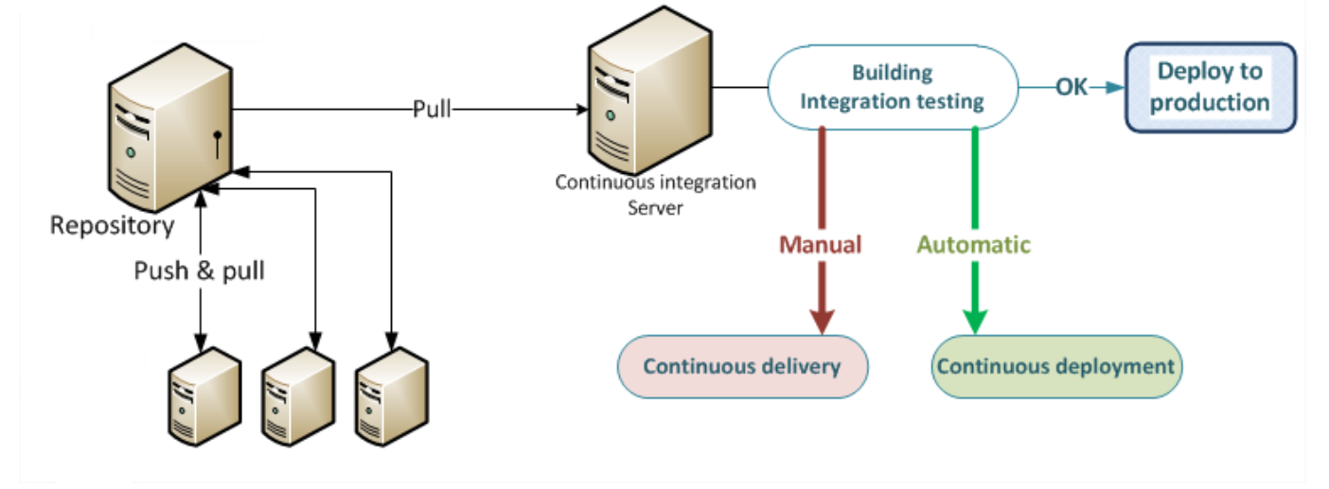

Figure 1 Continuous delivery and continuous deployment

Continuous Deployment is the next logical step of continuous delivery: once everything is smoothly working, every change that passes the automated tests is deployed to production automatically. The goal is to get the new features that the developers are creating, out to the customers and users as soon as possible.

The CD covers the following five steps:

* Build/CI – Types of builds, access control
* Environment Provisioning – Creating and maintaining target environments
* Deployment - Handle different components in different environments
* Test Management – Automated testing
* Release Management

shows relations between Continuous Integration, Delivery and Deployment: Continuous Delivery (CD) starts with Continuous integration (CI) and Continuous deployment is the next step of continuous delivery (CD).

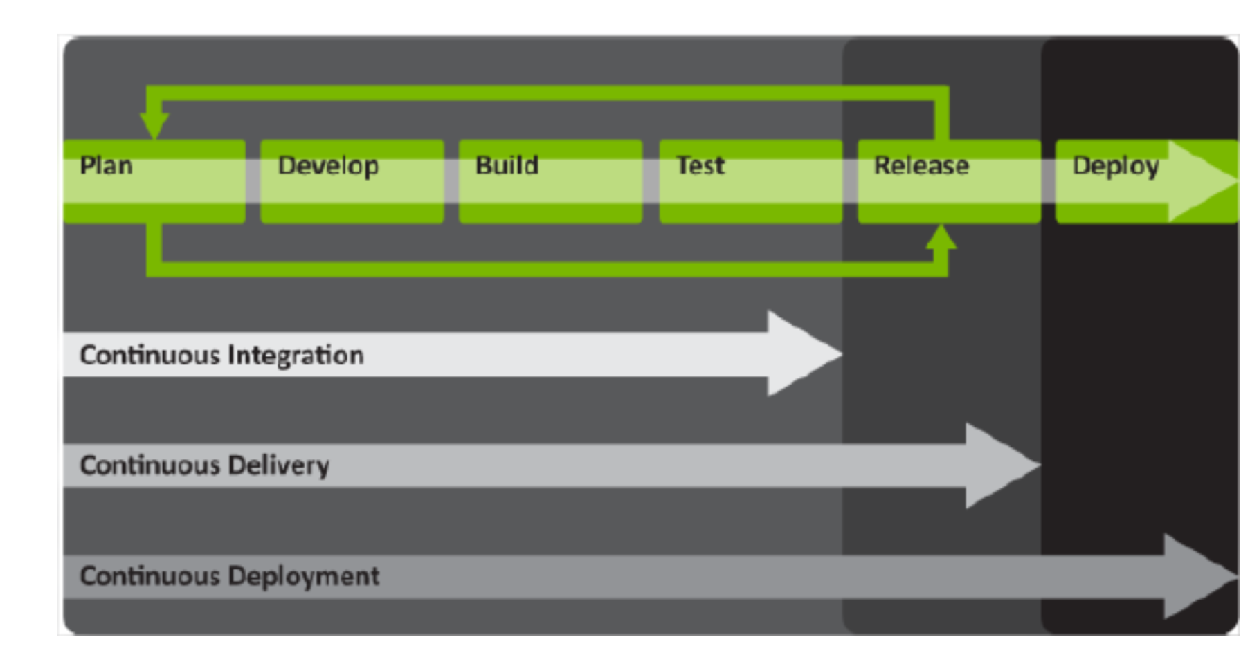

Figure 2 Continuous Integration, Delivery and Deployment

However, we cannot overlook Continuous Delivery barriers:

* **Organization culture**: is probably the most important aspect to consider when adopting sustainable Continuous Delivery principles. The adoption of DevOps should be carried out from top to bottom.
* **Lack of integrated development and operations**: Continuous Delivery and DevOps are working towards common objectives by enhancing business value through quick software delivery, within a culture that enables collaboration and understanding between crossfunctional teams.

The final aim to apply DevOps practices is to change from project management to a product concept in order to ease the integration and deployment phase. The release can then reach the users and the market quickly and efficiently thanks to robust releases.

# Agile methodologies and how to apply them to the project

Agile is a set of practices against the traditional Waterfall7 culture. The term was chosen on February 2001 with the Agile Manifesto [2] where a group of experts from several groups agreed upon a common ground for Software

Development cycle adaptable to changeable environment in the real world needs where requirements are not fixed from the beginning of the project focusing on:

* Individuals and interactions over processes and tools
* Working software over comprehensive documentation
* Customer collaboration over contract negotiation
* Responding to change over following a plan

## Scrum

Scrum is the widest-used agile methodology. The philosophy of Scrum is based in the continuous and rapid adaptation to client requirements through a set of underlying values and principles such as roles, workflow and artefacts:

**Artifacts**

* **User stories**, requirements written like “As a <type of user>, I want <some goal> so that <some reason>”.
* **Product Backlog**, an ordered list of everything that might be needed in the provided by the Product Owner.
* **Sprint Backlog**, a “to do” prioritized list or user stories.
* **Increment**, a coded, tested and usable piece of software (the pilots) provided at the end of each sprint by the development; the Increment is the sum of all the Product Backlog items completed and the value of the increments of all previous Sprints.

**Roles**

**Product Owner**, optimize the product value and manage the product backlog.

**Development Team**, a self-managed group who implement the user stories generated by the Product Owner.

**Scrum Master**, manage the Scrum process and remove communication barriers.

**Workflow**

* **Daily sprints**, daily meetings of 5 to 15 minutes maximum with a clear target for all the development team: work was done yesterday, work to be done today and problems found.
* **Sprint planning**, monthly meetings (depends on the sprint duration) where the identification of the user stories to be implemented in the next sprint is done.
* **Sprint review**, where the product owner should check that the result complies with the user stories.
* **Sprint retrospective**, where the team state benefits and drawbacks found during the last sprint.

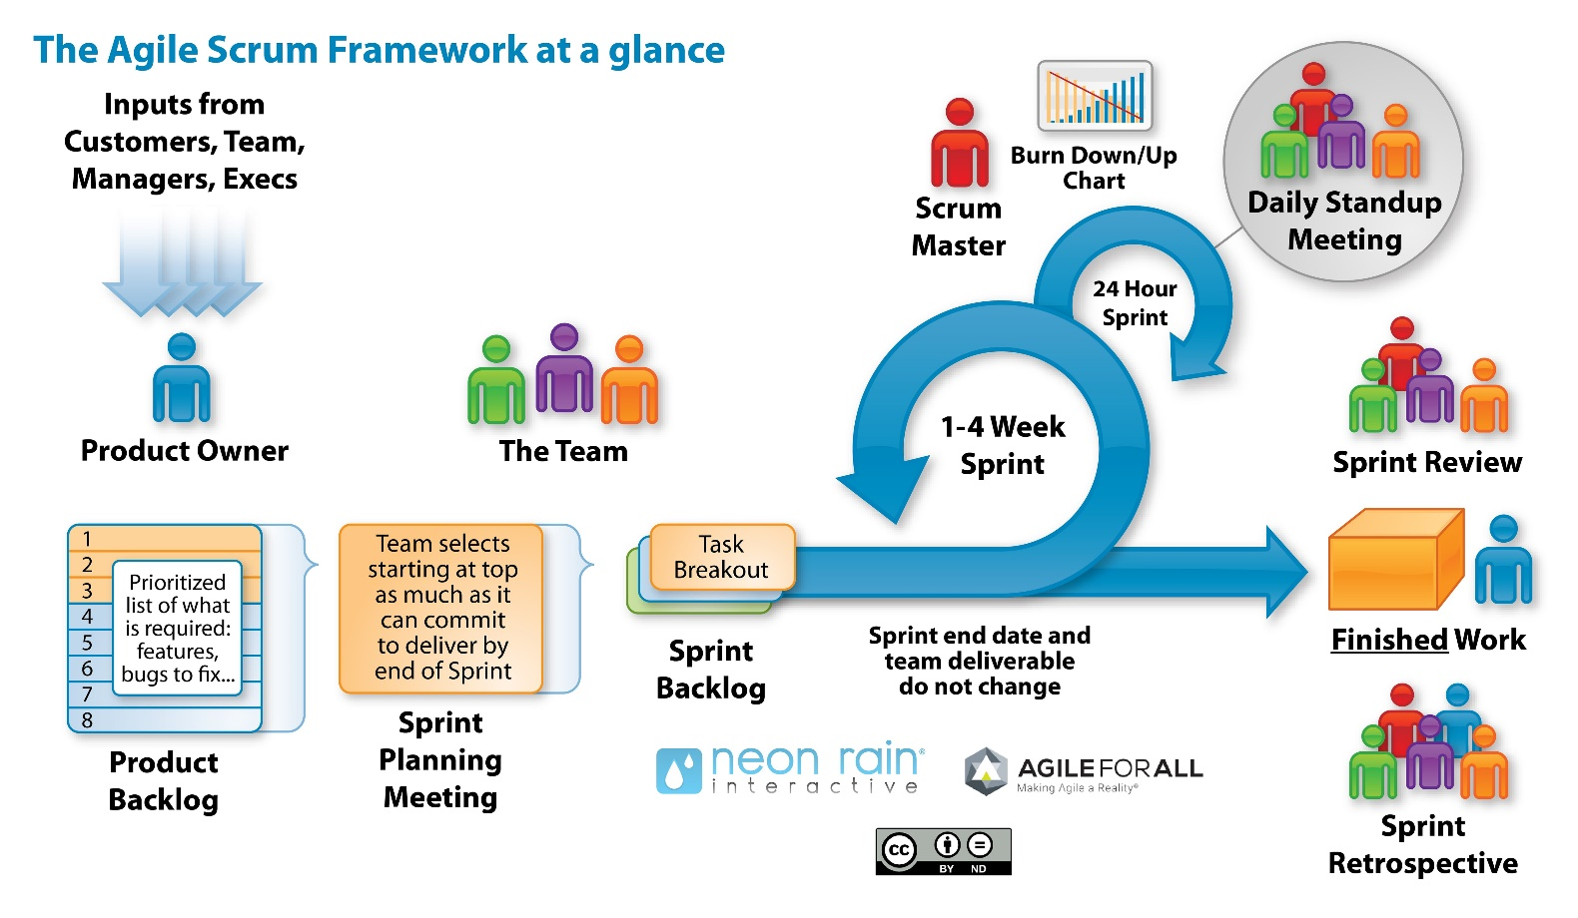

Figure 3 Scrum methodology full process

Following the Scrum principles mentioned above, Figure 5 breaks down the process of doing Scrum. The Product Backlog is prepared by the Product Owner covering the requirements (what is expected from the user view) written as meaningful user stories. The Development Team together with the Product Owner and guided by the Scrum Master configures the initial Sprint Backlog in the Initial Sprint Planning, the result is a “to do” prioritized list of user stories. Each user story is then broken down into tasks. Those tasks with more prioritized value are placed on the Sprint Backlog, which means, to be done on the next sprint. At the end of each sprint the Increment is calculated. The results are shown to the Product Owner during the Sprint Review. Finally, during the Sprint Retrospective the Development Team discusses about the last sprint and configures the next one.

From experience, Scrum is learned by doing Scrum with the support of experts and people prone to quickly adapt to new requirements (maybe a Darwinian adaptation) having effective communication and feedback, which will allow improving the procedure.

## Test-Driven Development

“Test-driven development (TDD) is a software development process that relies on the repetition of a very short development cycle: requirements are turned into very specific test cases, then the software is improved to pass

the new tests, only. This is opposed to software development that allows software to be added that is not proven to meet requirements”.

The idea behind TDD is again to change the culture of the developers. Instead of starting by developing the product and later on building the tests to prove that it is working as expected, the implementer should specify the tests that the product must pass. In the CollaBoard project, the recommendation is to describe the acceptance tests at the same time then the user story, although it is not required to apply TDD fully.

## eXtreme Programming (XP)

“Extreme programming (XP) is a software development methodology which is intended to improve software quality and responsiveness to changing requirements”10. XP attempts to reduce the cost of changes in requirements

by having multiple short development cycles, rather than a long one. Extreme Programming emphasizes teamwork: managers, customers, and developers are all equal partners in a collaborative team.

Tools involved in CI and CD are part of XP to speed up the process of integrating and testing the product. The first step is to apply Agile methodologies to extract what the Product Owner wants and later on through iterative process of self-building and deployment to be able to release often robust versions of the product.

## Pomodoro technique

The Pomodoro technique11 is a time management method developed by Francesco Cirillo in the late 1980s to avoid the multitasking problem. The Pomodoro technique splits the work into intervals to allow focusing on one task at a time for a certain period (25 minutes) receiving 5 or 15 minutes break. If you manage to do a whole 25 minutes without checking your e-mail, distracting yourself with your phone or switching to another task, then you can address 5 minutes to other enjoyable tasks. After four successful Pomodoro accomplished it is possible to have a break for 15 minutes. The ground behind this technique is that human brain cannot stay focus indefinitely doing some task becoming then waste time. This method provides the possibility to concentrate for 25 minutes in only and only

one task.

## Agile in CollaBoard project

## Choosing the right process

In Azure Dev Ops anytime a project is created the creator has to choose create a project, needs to choose a process or process template based on the process model you use.

* A process defines the building blocks of the work item tracking system and supports the Inheritance process model for Azure Boards. This model supports customization of projects through a WYSIWYG user interface.
* A process template defines the building blocks of the work item tracking system as well as other sub-systems you access through Azure Boards or an on-premises Azure DevOps Server or Team Foundation Server (TFS). It supports Hosted XML and On-premises XML process models which support customization of projects through the modification and import of XML definition files.

The work tracking objects contained within the default processes and process templates—Basic, Agile, CMMI, and Scrum—are the same and are summarized below. The Basic process is available from Azure DevOps Server 2019.1 and later versions. For simplicity, they are referred to as a "process."

### Basic, Agile, Scrum, and CMMI

The default processes differ mainly in the work item types (WITs) they provide for planning and tracking work.

Basic is the most lightweight and is in a selective Preview. Scrum is the next most light-weight. Agile supports many Agile method terms, and CMMI, which stands for Capability Maturity Model Integration, provides the most support for formal processes and change management.

**Basic**

Choose Basic when your team wants the simplest model that uses Issues, Tasks, and Epics to track work. Note: Basic is currently in a selective Preview for new users of Azure Boards only.

Tasks support tracking Remaining Work.

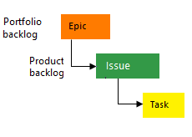

Figure 4 Basic Azure DevOps process diagram

**Agile**

Choose Agile when your team uses Agile planning methods, including Scrum, and tracks development and test activities separately. This process works great if you want to track user stories and (optionally) bugs on the Kanban board, or track bugs and tasks on the taskboard.

Tasks support tracking Original Estimate, Remaining Work, and Completed Work.

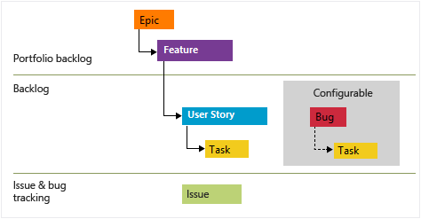

Figure 5 Agile Azure DevOps process diagram

**Scrum**

Choose Scrum when your team practices Scrum. This process works great if you want to track product backlog items (PBIs) and bugs on the Kanban board, or break PBIs and bugs down into tasks on the taskboard.

This process supports the Scrum methodology as defined by the Scrum organization.

Tasks support tracking remaining work only.

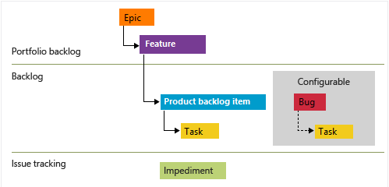

Figure 6 Scrum Azure DevOps process diagram

**CMMI**

Choose CMMI when your team follows more formal project methods that require a framework for process improvement and an auditable record of decisions. With this process, you can track requirements, change requests, risks, and reviews.

This process supports formal change management activities. Tasks support tracking Original Estimate, Remaining Work, and Completed Work.

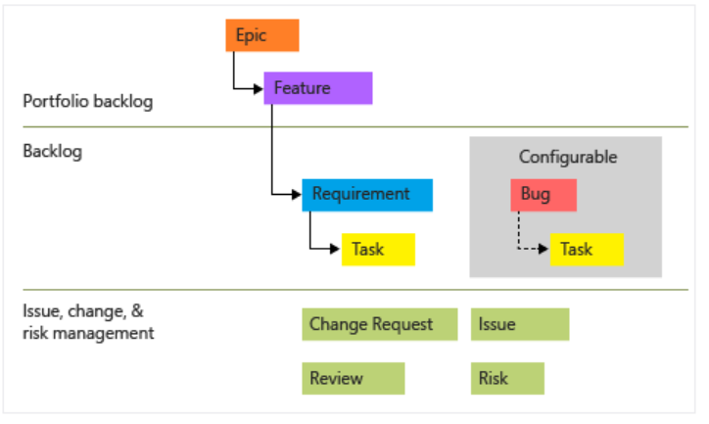

Figure 7 CMMI Azure DevOps process diagram

### Main distinctions among the default processes

The default processes are designed to meet the needs of most teams. If your team has unusual needs and connects to an on-premises server, you can customize a process and then create the project. Or, you can create a project from a process and then customize the project.

The following table summarizes the main distinctions between the WITs and states used by the three default processes.

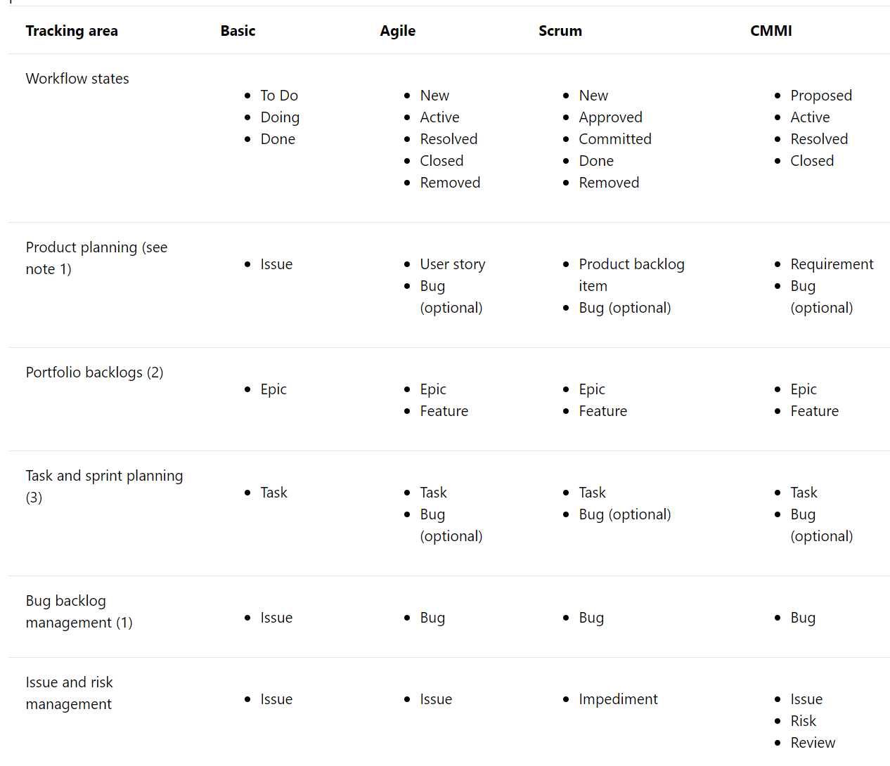

Notes:

1. You can add these WITs from the product backlog or Kanban board. The product backlog shows a single view of the current backlog of work that can be dynamically re-ordered and grouped. Product owners can quickly prioritize work and outline dependencies and relationships.

Also, each team can configure how they want bugs to show up on their backlogs and boards.

1. With portfolio backlogs you can define a hierarchy of backlogs to understand the scope of work across several teams and see how that work rolls up into broader initiatives. Each team can configure which portfolio backlogs appear for their use.
2. You can define tasks from the sprint backlog and taskboard. With capacity planning, teams can quickly determine if they are over or under capacity for a sprint.

### Workflow states, transitions, and reasons

Workflow states support tracking the status of work as it moves from a new state to a closed or a done state.

Each workflow consists of a set of states, the valid transitions between the states, and the reasons for transitioning the work item to the selected state.

The following diagrams show the typical forward progression of those WITs used to track work and code defects for the three default processes. They also show some of the regressions to former states and transitions to removed states. Each image shows only the default reason associated with the transition.

**Basic process workflow**

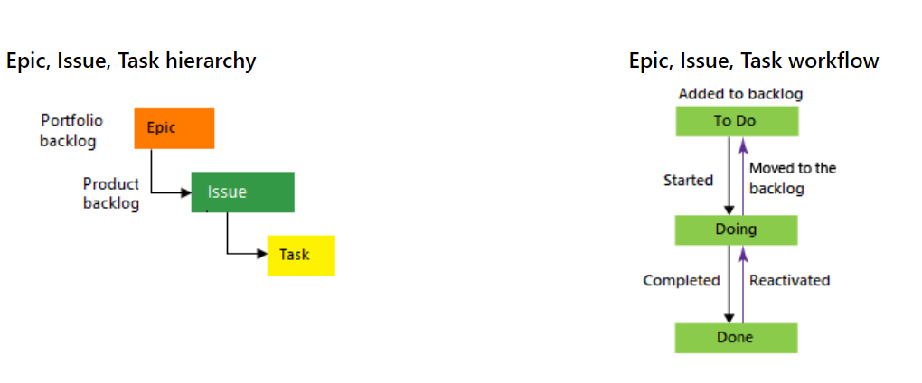

Figure 8 Basic process workflow

**Agile process workflow**

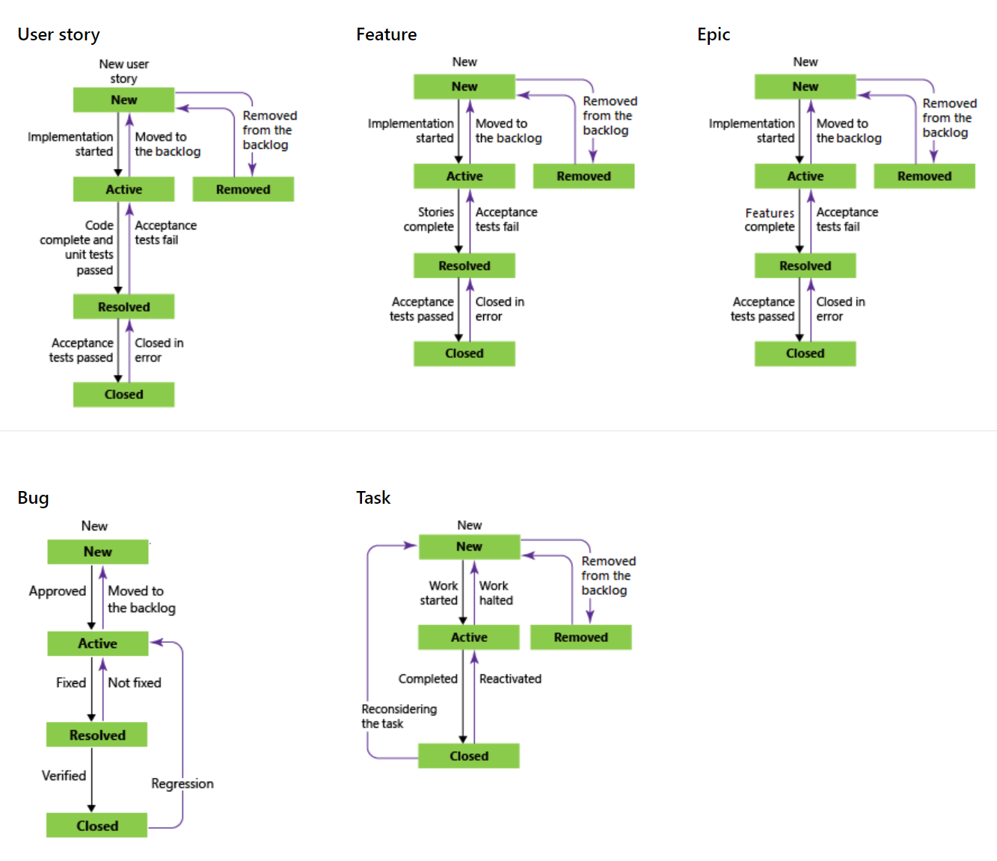

Figure 9 Agile process workflow

**Scrum process workflow**

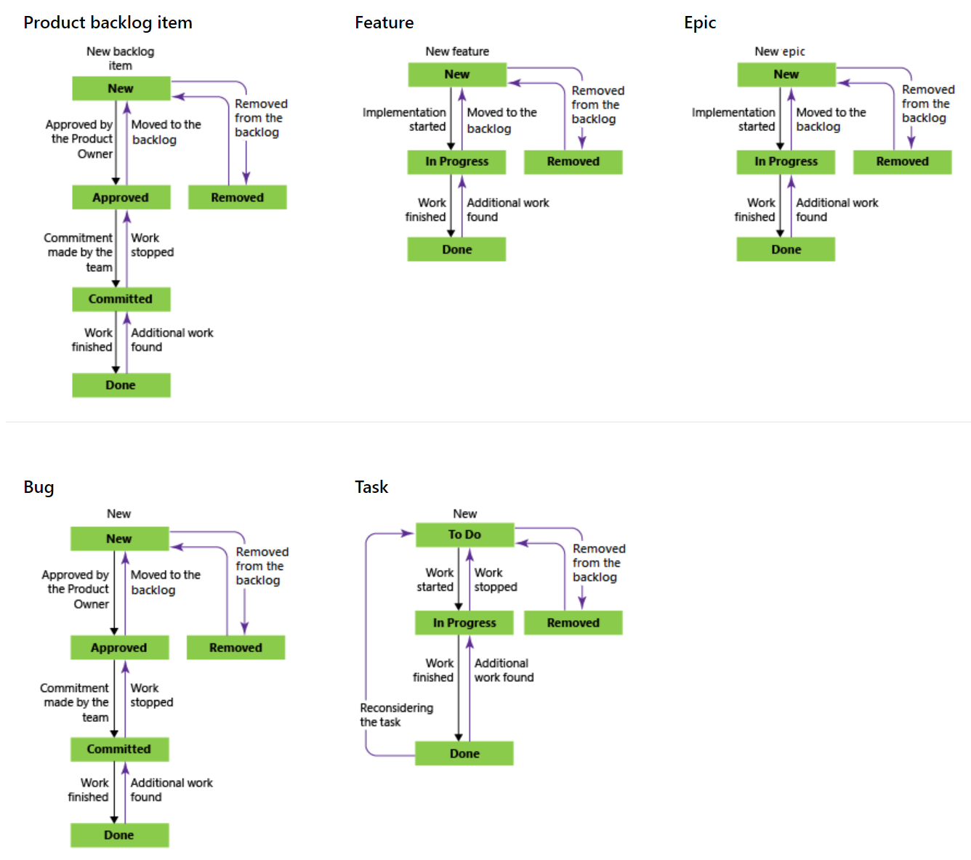

Figure 10 Scrum process workflow

**CMI process workflow**

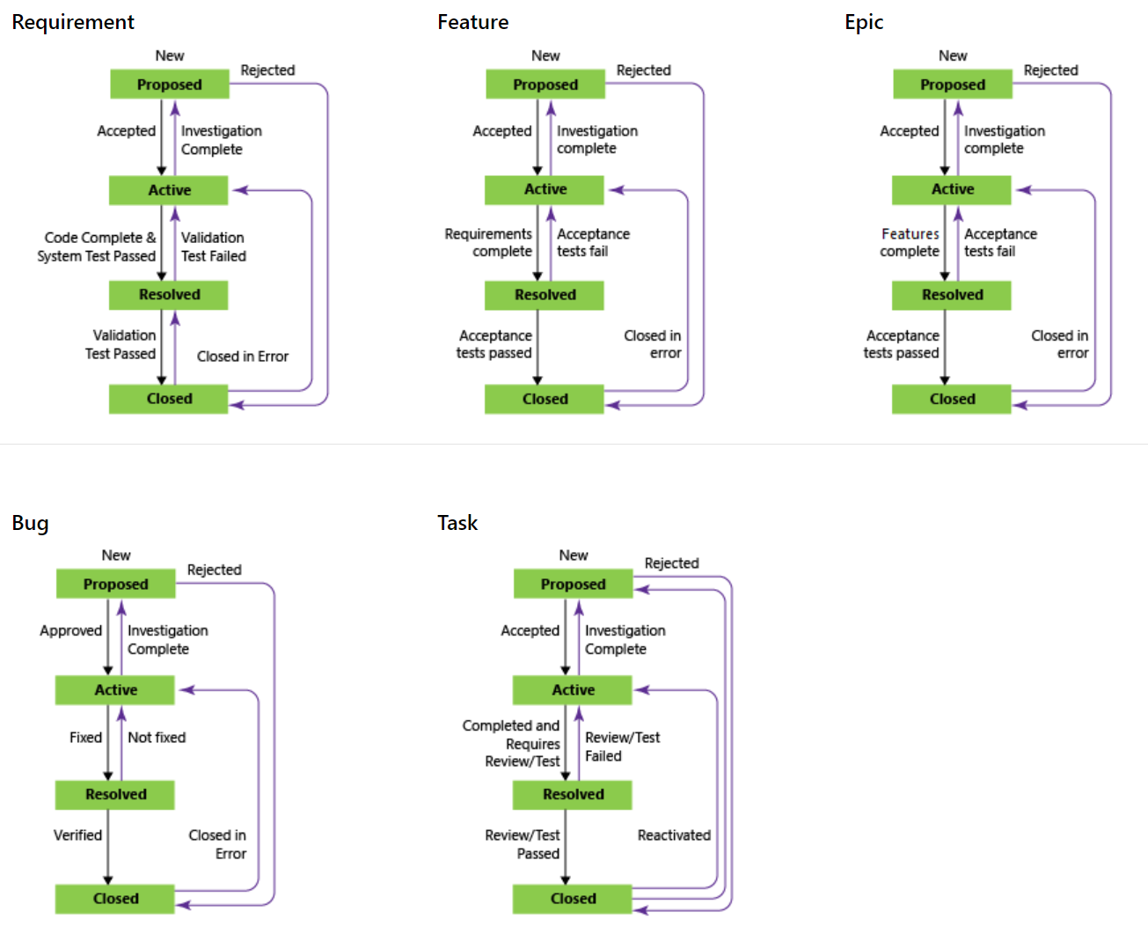

Figure 11 CMI process workflow

# The Agile process in CollaBoard

The Agile process supports the following work item types (WITs) to plan and track work, tests, feedback, and code review. With different WITs you can track different types of work—such as features, user stories, and tasks. These artifacts are created when you create a project using the Agile process. They are based on Agile principles and values.

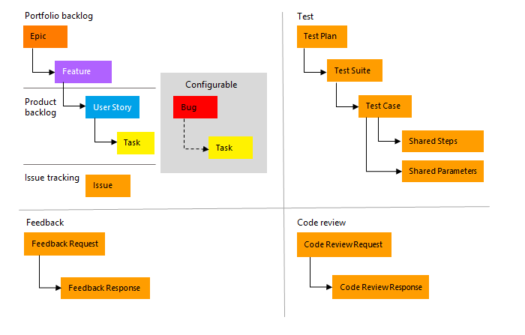

Figure 12 The Agile process in CollaBoard

## Plan and track work with Agile

You build your project plan by creating a backlog of user stories that represent the work you want to develop and ship. You track bugs, tasks, and blocking issues using the bug, task, and issue WITs. To support portfolio management, teams create features and epics to view a roll up of user stories within or across teams..

The essential flow for getting started is as shown in the picture below.

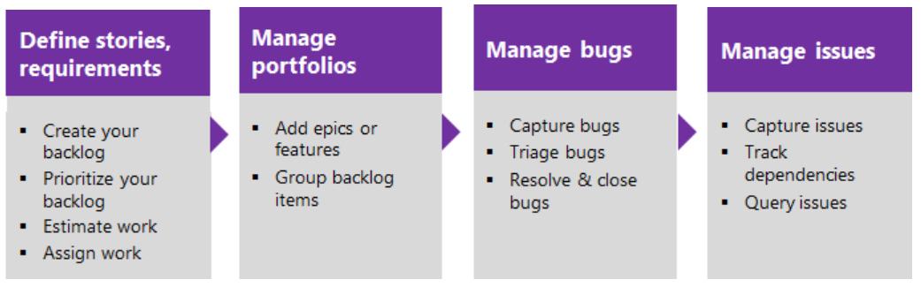

Figure 13 The essential flow

## Agile process work item types and workflow

Teams use the work item types (WITs) provided with the Agile process to plan and track progress of software projects. Teams define user stories to manage the backlog of work and then, using the Kanban board, track progress by updating the status of those stories.

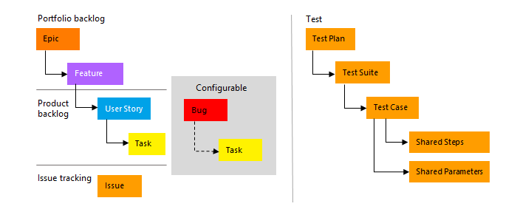

Figure 14 The Agile Workflow

To gain insight into a portfolio of features, scenarios, or user experiences, product owners and program managers can map user stories to features. When teams work in sprints, they define tasks which automatically link to user stories. If you are new to the Agile process, review the section Plan and track work with Agile to get started.

Using the web portal or Microsoft Test Manager, testers can create and run test cases. Bugs and issues are used to track code defects and blocking issues.

## Define user stories

User stories define the applications, requirements, and elements that teams need to create. Product owners typically define and stack rank user stories. The team then estimates the effort and work to deliver the highest priority items.

Create user stories from the quick add panel on the product backlog page. From that page, you can also drag-and-drop items to reorder them or map them to features.

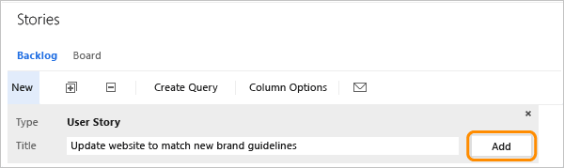

Figure 15 Creating a new user story

Later, you can open each user story to provide more details and estimate the story points.

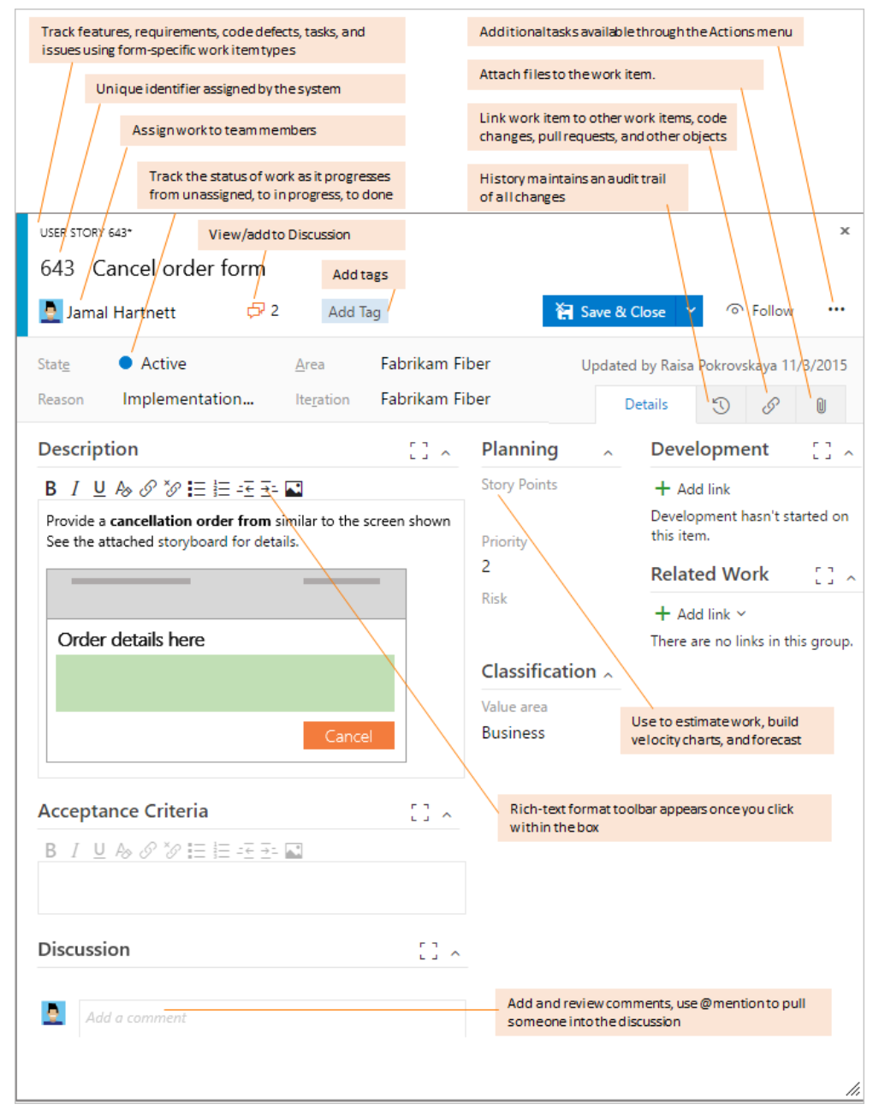

Figure 16 User story detail

By defining the Story Points, teams can use the forecast feature and velocity charts to estimate future sprints or work efforts. By prioritizing the user stories on the backlog page (which is captured in the Stack Rank field), product owners can indicate which items should be given higher priority.

Use the following guidance and that provided for fields used in common across work item types when filling out the form.

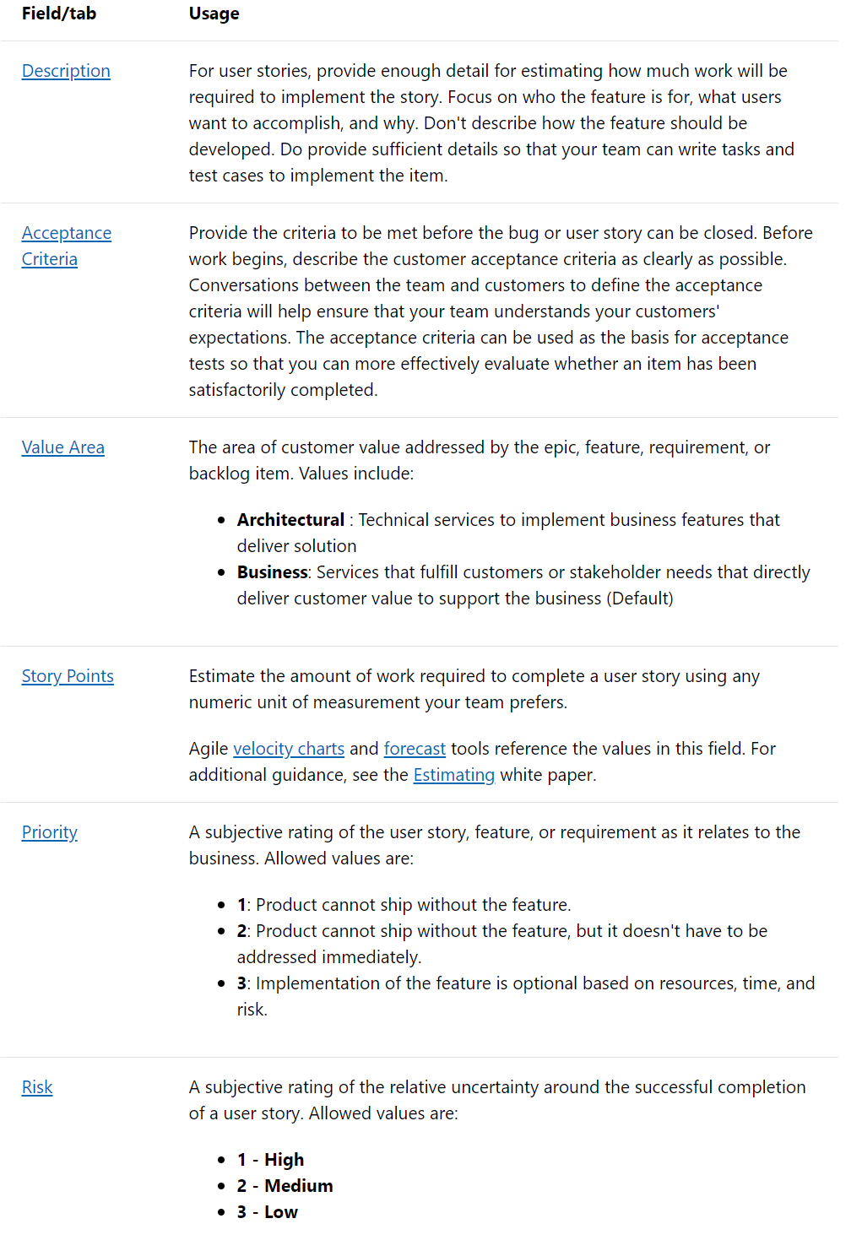

Figure 17 User story field usage

## Capture comments in the Discussion section

Use the Discussion section to add and review comments made about the work being performed.

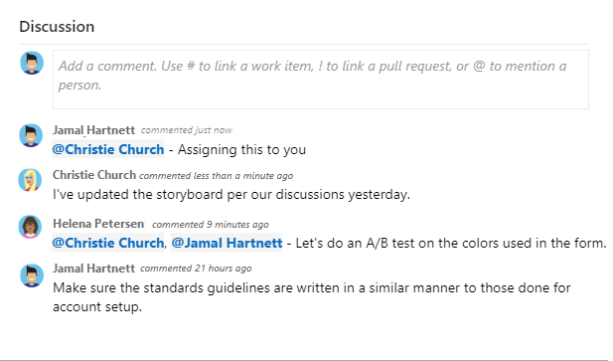

Figure 18 The discussin section

The rich text editor tool bar displays below the text entry area when you click your cursor within each text box that can be formatted.

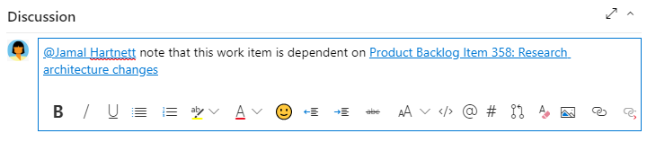

Figure 19 Discussion text editor

## Track progress

As work progresses, you change the State field to update the status. Optionally, you can specify a reason. The state and reason fields appear on the work item form in the header area

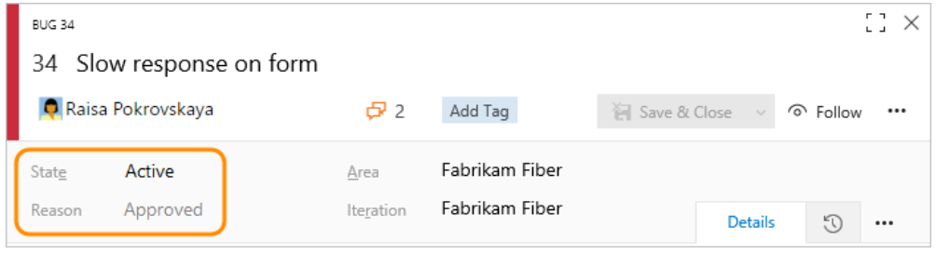

Figure 20 Work item status

### Agile workflow states

By updating the workflow, teams know which items are new, in progress, or completed. Most WITs support transition both forward and backward from each workflow state. These diagrams show the main progression and regression states of the user story, bug, and task WITs.

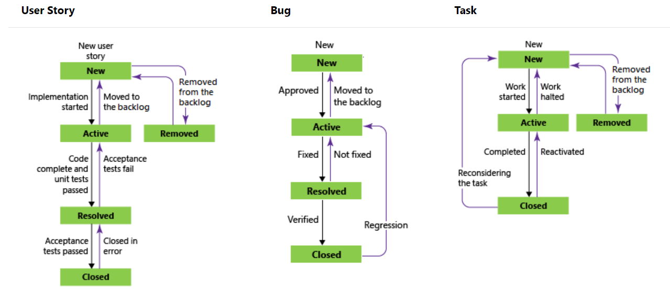

Figure 21 progression and regression states of the user story, bug, and task

A typical workflow progression for a user story follows:

* The product owner creates a user story in the New state with the default reason, New user story
* The team updates the status to Active when they decide to complete the work during the sprint
* A user story is moved to Resolved when the team has completed all its associated tasks and unit tests for the story pass
* A user story is moved to the Closed state when the product owner agrees that the story has been implemented according to the Acceptance Criteria and acceptance tests pass.

### Update status with Kanban or taskboards

Teams can use the Kanban board to update the status of requirements, and the sprint taskboard to update the status of tasks. Dragging items to a new state column updates both the State and Reason fields.

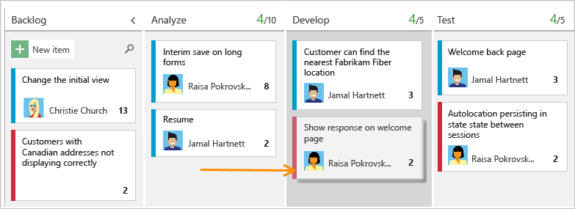

Figure 22 The Azure DevOps Kanban board

You can customize the Kanban board to support additional swim lanes or columns. For additional customization options, see Customize your work tracking experience.

## Map user stories to features

When you manage a suite of products or user experiences, you might want to view the scope and progress of work across the product portfolio. You can do this by defining features and mapping user stories to features.

Using portfolio backlogs, you can drill down from one backlog to another to view the level of detail you want. Also, you can use portfolio backlogs to view a rollup of work in progress across several teams when you setup a hierarchy of teams.

## Define tasks

When your team manages their work in sprints, they can use the sprint backlog page to break down the work to be accomplished into distinct tasks.

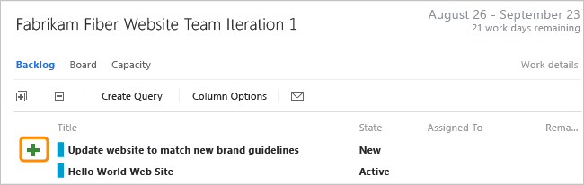

Figure 23 Defining a Task

Name the task and estimate the work it will take.

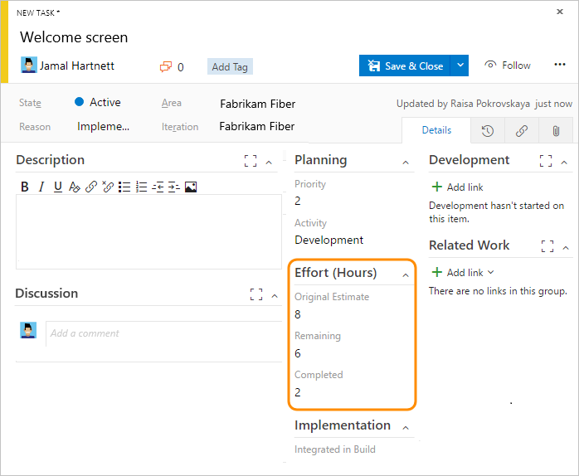

Figure 24 Naming the Task and estimate the work it will take

Using Agile processes, teams forecast work and define tasks at the start of each sprint, and each team member performs a subset of those tasks. Tasks can include development, testing, and other kinds of work. For example, a developer can define tasks to implement user stories, and a tester can define tasks to write and run test cases.

When teams estimate work using hours or days, they define tasks and the Remaining Work and Activity (optional) fields.

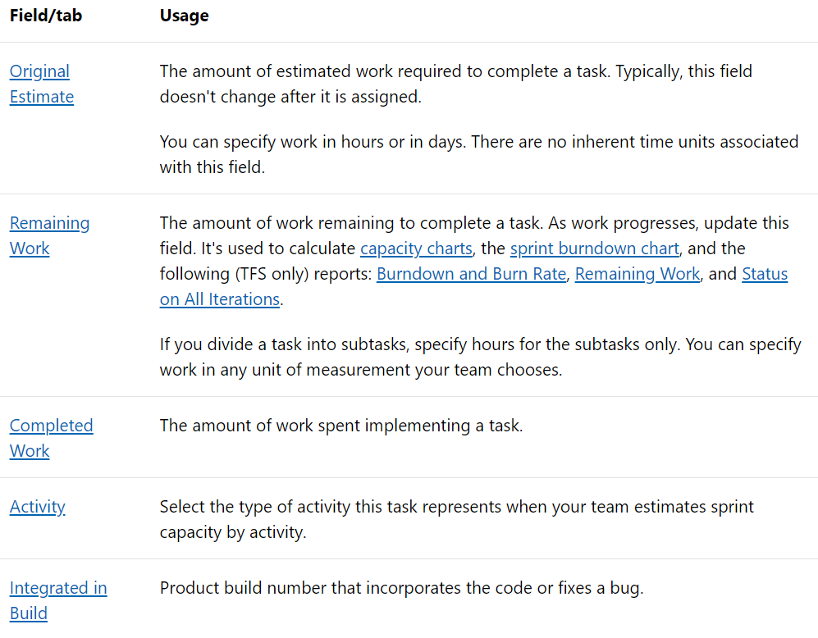

If you use Microsoft Project to assign resources and track a schedule, you can update these fields using Project.

## Track test progress

### Test user stories

From the web portal or Test Manager, you can create test cases that automatically link to a user story or bug. Or, you can link a user story to a test case from the Links tab icon  (links tab).

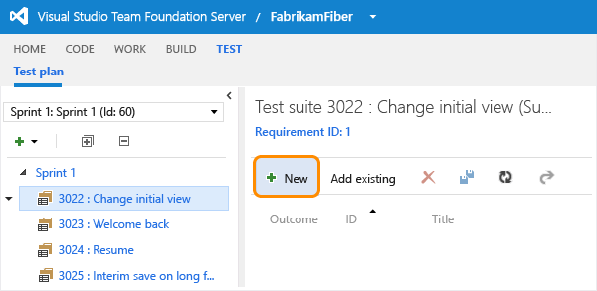

Figure 25 Create test cases that automatically link to a user story or bug

The test case contains a number of fields, many of which are automated and integrated with Test Manager and the build process.

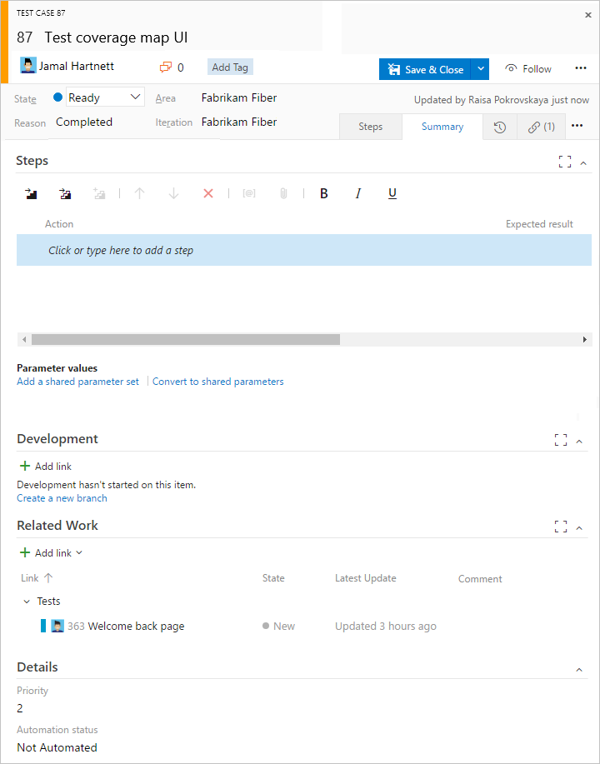

Figure 26 Link to user stories

The Links tab icon (links tab) captures the links to user stories and bugs in a test case. By linking user stories and bugs to test cases, the team can track the progress made in testing each item. By defining these links, you support information that appears in the Stories Overview Report report.

**Track code defects**

You can create bugs from the web portal, Visual Studio, or when testing with Test Manager.

## Definitions for common WIT fields

The following fields and tabs appear in most work items. Each tab is used to track specific information, such as History tab icon history, Links tab icon links, or Attachment tab icon attachments. These three tabs provide a history of changes, view of linked work items, and ability to view and attach files.

The only required field for all WITs is Title. When the work item is saved, the system assigns it a unique ID. The form highlights required field in yellow. For information about other fields, see Work item field index.

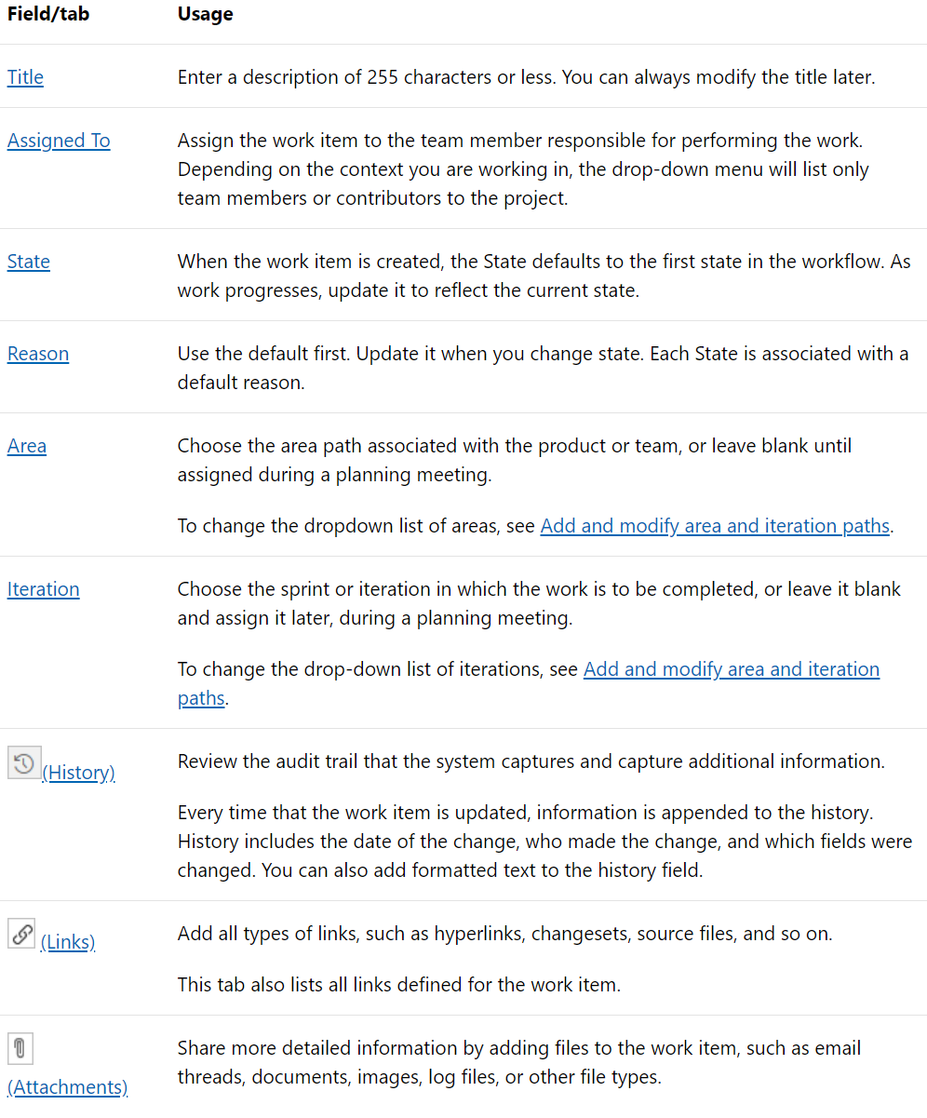

## Customize work item types

You can add fields, change the workflow, add custom rules, and add custom pages to the work item form of most work item types. You can also add custom work item types. For details, see Customize an inheritance process.

## Track issues

Issues are used to track events that may block progress or shipping a user story. Bugs, on the other hand, are used to track code defects. You can add an issue from the New work item widget added to a team dashboard, or from the New menu on the Queries page.

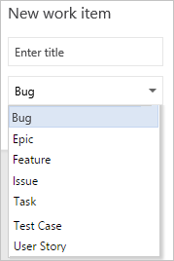

Figure 27New Bug

Work items you add from the widget are automatically scoped to your team's default area and iteration paths. To change the team context, see Switch team context.

### Track business value

You can use the Priority field to differentiate the value of various stories. Or, you can add a custom field to the User Story WIT that tracks the relative value of stories. To learn how, see Customize a field for a process.

### Backlog list order

The Stack Rank field is used to track the relative ranking of user stories, however by default it doesn't appear on the work item form. The sequence of items on the backlog page is determined according to where you have added the items or moved the items on the page. As you drag items, a background process updates this field.

## Creating product backlog

Your product backlog corresponds to your project plan, the roadmap for what your team plans to deliver. You create your product backlog by adding user stories, backlog items, or requirements.

After you define it, you have a prioritized list of features and requirements to build. Your backlog also provides a repository of all the information you need to track and share with your team.

Your backlog consists of a list of work items. You use work items to share information, assign work to team members, track dependencies, organize work, and more. Because the most important work appears at the top of the list, your team always knows what to work on next.

### Prerequisites

* You must connect to a project. If you don't have a project yet, create one.
* You must be added to a project as a member of the Contributors or Project Administrators security group. To get added, Add users to a project or team.
* To add or modify work items, you must be granted Stakeholder access or higher. For details, see About access levels.
* To view or modify work items, you must have your View work items in this node and Edit work items in this node permissions set to Allow. By default, the Contributors group has this permission set. To learn more, see Set permissions and access for work tracking.

### Backlog from the web portal

From your web browser, open your product backlog.

1. (1) Check that you have selected the right project, (2) choose **Boards>Backlogs**, and then (3) select the correct team from the team selector menu.

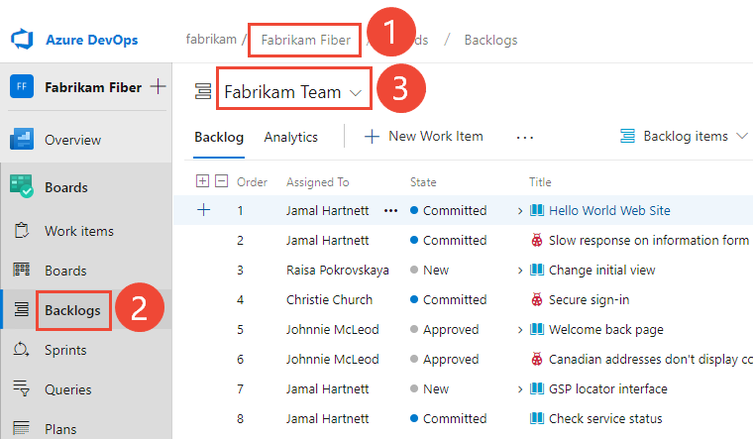

Figure 28 Backlog from the web portal

To select another backlog, open the selector and then choose a different team or select the View Backlog directory option. Or, enter a keyword in the search box to filter the list of team backlogs for the project.

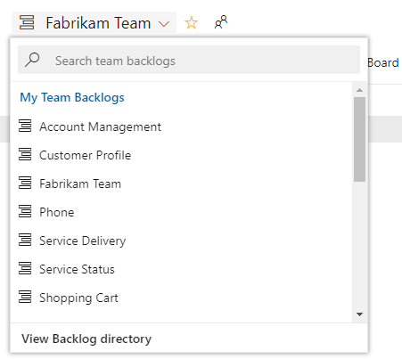

Figure 29 select another backlog

1. Check that you have selected Stories (for Agile), Issues (for Basic), Backlog items (for Scrum), or Requirements (for CMMI) as the backlog level.

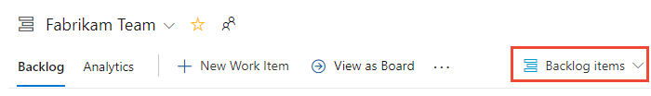

Figure 30 backlog level

1. (Optional) To choose which columns should display and in what order, choose the actions icon and select Column options. To learn more, see Change column options.

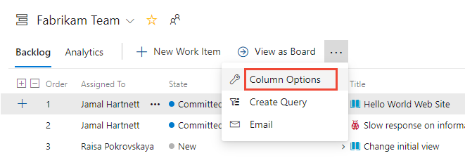

Figure 31 which columns should display

### Determine if bugs should appear on your backlog

You can choose how you want to manage bugs. Some teams like to track bugs along with requirements on the backlog. Other teams like to track bugs as tasks performed in support of a requirement. The bugs then appear on their taskboard.

If you use the Scrum process, your default setup is to track bugs along with product backlog items (PBIs). If you work in a project based on the Agile or CMMI processes, bugs don't automatically appear on your backlog.

Talk with your team to determine how they want to manage bugs. Then change your team settings accordingly.

### Convert ideas into backlog items or stories

Your backlog shows work that you plan to do or have started to work on. As soon as the state of a work item is set to Done or Completed, the work item no longer shows up on your backlog. You can use the backlog controls to filter or change your view.

Users with Stakeholder access can only add work items to the end of the backlog. For details, see About access levels.

1. Before you add work items, select the  view options icon and turn the slider for Parents and Forecasting to Off. Optionally, turn In Progress Items on or off.

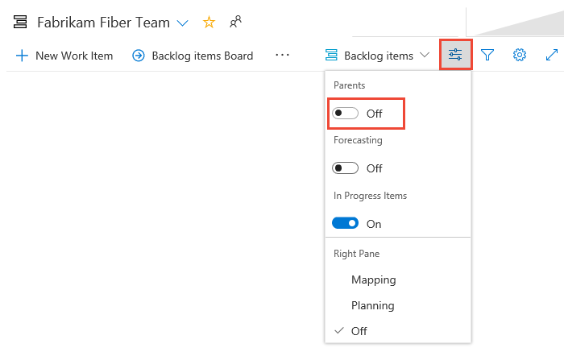

Figure 32 view options

1. To add a work item, select  **New Work Item** and enter a title. Then press Enter or select **Add to top**.

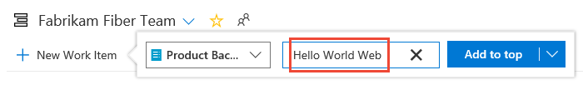

Figure 33 enter a title

1. Repeat this step to capture all your ideas as work items.

### Move items into priority order

After you have some items in your backlog, you can reorder them to create a prioritized list of work. Review and prioritize your backlog frequently to help your team know what's most important to deliver next.

To reorder a backlog, you must have Basic or higher level access. For details, see About access levels.

To reorder your backlog, drag the work items. Or, if you prefer to use the keyboard, hold down the Alt key and use the up and down arrows.

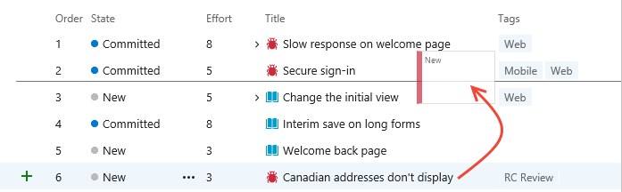

Figure 34 reorder your backlog

### Add details and estimates

Building and prioritizing your backlog provides you with a high-level roadmap. Before your team can start work on any item, they need more details. You capture these details within the work item form.

To open each item, double-click or press Enter. Then add all the information you want to track. Enter as much detail as the team needs to:

* Understand the scope.
* Estimate the work required.
* Develop tests.
* Ensure that the end product meets acceptance criteria.

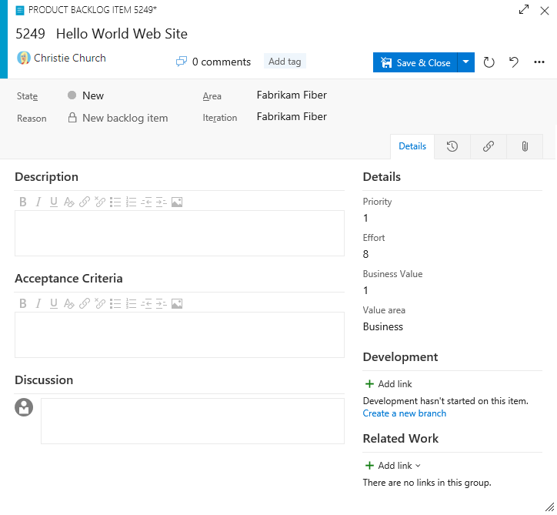

Figure 35 Add details and estimates

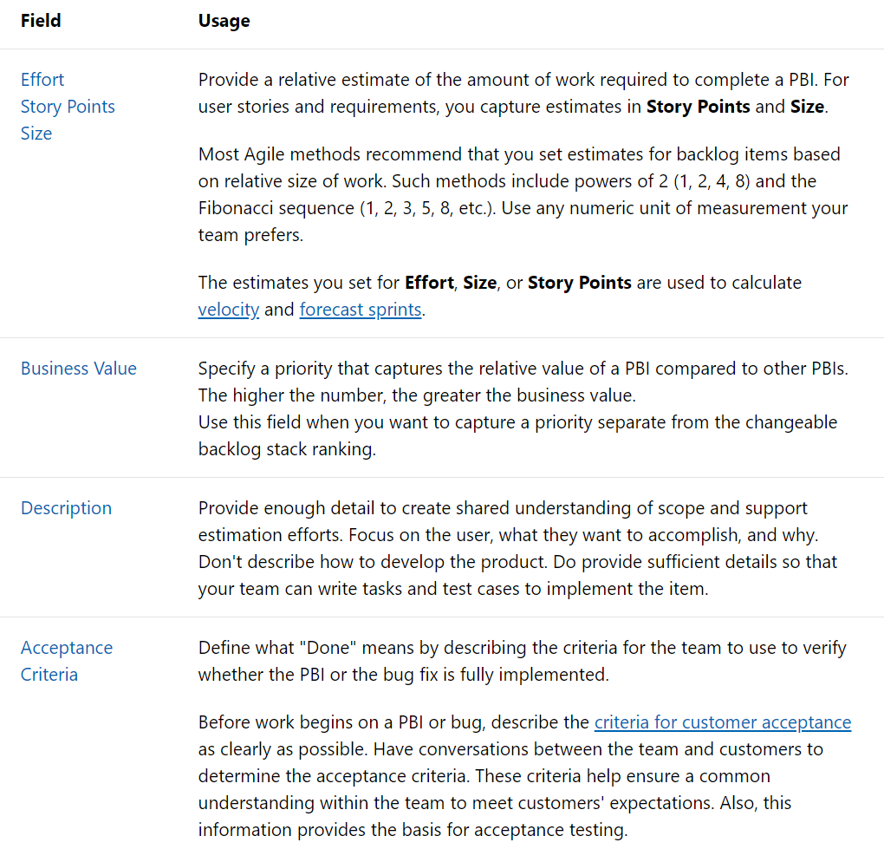

## Organizing the backlog, map child work items to parents

After you've added features or epics to your portfolio backlog, you can quickly organize your backlog by mapping backlog items to them. With features and epics, you can quickly add and group items into a hierarchy, drill up or down within the hierarchy, reorder and reparent items, and filter hierarchical views.

In this chapter we will walkthrough how to:

* Open your product backlog or portfolio backlog
* View the tree hierarchy
* Group backlog items using the Mapping pane
* Reparent items using drag-and-drop or the Change parent option

### Prerequisites

* You must connect to a project. If you don't have a project yet, create one.
* You must be added to a project as a member of the Contributors or Project Administrators security group. To get added, Add users to a project or team.
* To add or modify work items, you must be granted Stakeholder access or higher. For details, see About access levels.
* To view or modify work items, you must have your View work items in this node and Edit work items in this node permissions set to Allow. By default, the Contributors group has this permission set. To learn more, see Set permissions and access for work tracking.

Users with Stakeholder access for a private project can't use drag and drop to map or reparent work items or change their sprint.

### Backlog from the web portal

Refer to the same paragraph on the Creating product backlog chapter

### Show parents and expand the tree hierarchy

1. To view Parents or a tree hierarchy, choose the  view options icon and slide **Parents** to **On**.

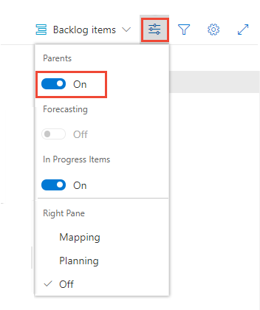

Figure 36 slide Parents to On.

The hierarchical view displays. From this view, you can reparent items by drag and drop, moving a child item to a new parent.

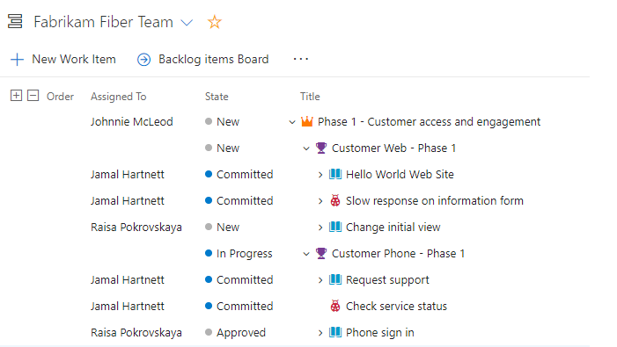

Figure 37 The hierarchical view displays

1. Use the expand  and collapse  icons to expand or collapse one level of the hierarchy.

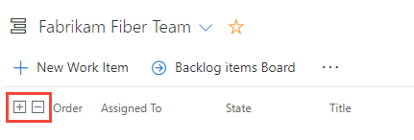

### Map items to group them under a feature or epic

If you've already created your backlog, and now you want to organize it, you can do that most easily by mapping child items to parents.

1. Choose the  view options icon and select Mapping.

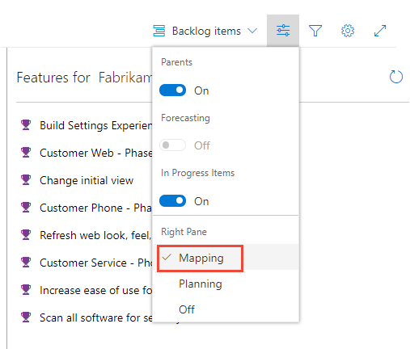

Figure 38 select Mapping

The Mapping pane displays immediately.

1. Find Unparented backlog items which will appear at the end of the parented set of backlog items. Parents must be turned on in view options.

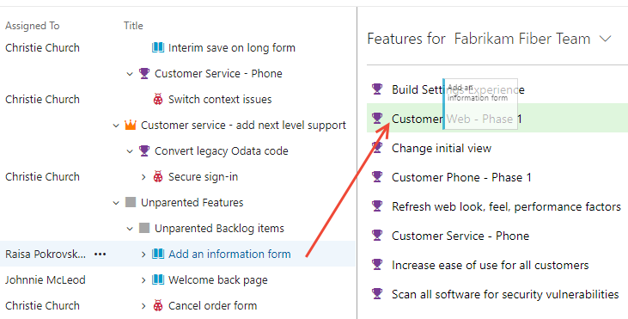

Figure 39 Find Unparented backlog

1. To map features to epics, select the Features backlog from the backlog selector. The Epics Mapping pane will automatically display.

You can multi-select work items on the backlog and sprint backlogs in the same way as multi-select works within query results.

It's the same process to map features to epics. From the Features backlog, drag features to an epic listed under the mapping pane.

### Change parent (re-parent) and reorder items

When you need to change the order or grouping, simply drag the item to its new location.

You can re-parent an item using the mapping pane, or simply drag it within the hierarchy to change its parent.

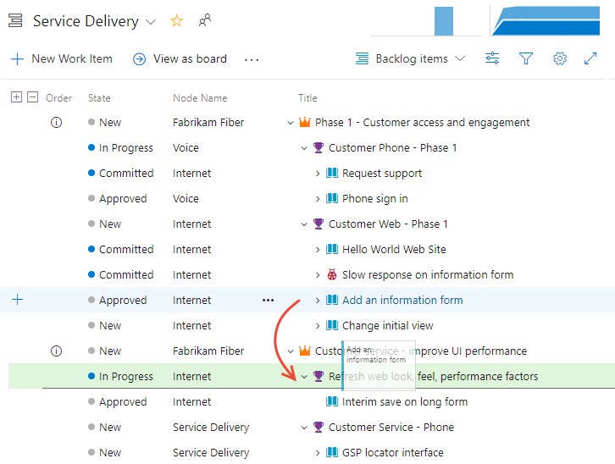

Figure 40 Change parent

You can only re-parent backlog items under other features, and features under other epics.

Also, to change an item's priority within a group, you can drag the item up or down within its hierarchical group. This works the same as when you moved items into priority order on your product backlog.

### Change parent of multiple backlog items

From the product backlog you can multi-select several work items and choose Change parent… to link the items to a parent work item item.

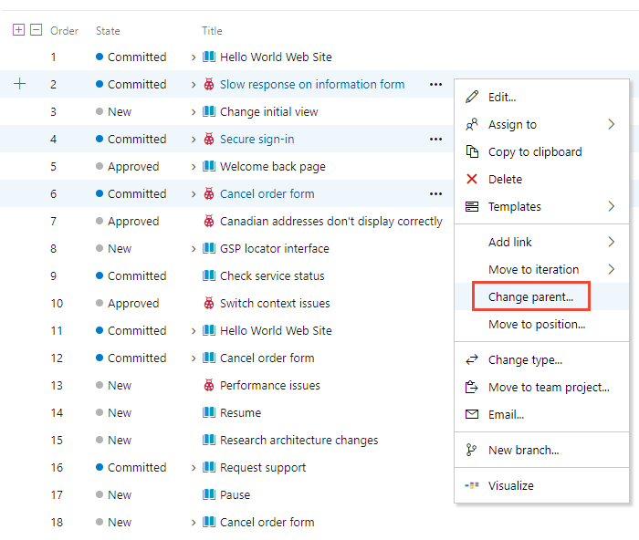

Figure 41 change parent

### Add portfolio backlog levels and boards

If you need more than two portfolio backlogs, you can add up to two more for a total of five backlog levels.

You can add them by customizing your process, adding new work item types, and then configuring your backlogs and boards. You can also add or modify the fields defined for a work item type (WIT) or add a custom WIT. For details, see Customize an inheritance process and Customize your backlogs or boards (Inheritance process).

## Define, triage, and manage bugs

How do you track and manage defects in your code? How do you make sure software problems and customer feedback get addressed in a timely manner to support high-quality software deployments? And, how do you do this while making good progress on new features?

At a minimum, you need a way to capture your software issues, prioritize them, assign them, and track progress. Moreover, you'll want to manage your bugs in ways that align with your Agile practices.

In a nutshell, you manage bugs through the following tasks:

* Capture information using the bug work item type
* Triage bugs by assigning a priority
* Update bug status throughout the bug lifecycle
* Monitor bug assignments and trends

Each team can choose how bugs show up on their backlogs and boards.

### Prerequisites

* You must connect to a project. If you don't have a project yet, create one.
* You must be added to a project as a member of the Contributors or Project Administrators security group. To get added, Add users to a project or team.
* To add or modify work items, you must be granted Stakeholder access or higher. For details, see About access levels.
* To view or modify work items, you must have your View work items in this node and Edit work items in this node permissions set to Allow. By default, the Contributors group has this permission set. To learn more, see Set permissions and access for work tracking.
* To create new tags to add to work items, you must have Basic access or higher and have the project-level Create new tag definition permissions set to Allow. By default, the Contributors group has this permission set. Even if the permission is explicitly set for a Stakeholder, they won't have permission to add new tags, as they are prohibited through their access level.

### Define and list bugs

When bugs are managed along with requirements, you can add them through the product backlog or Kanban board. When bugs are managed along with tasks, you can add them to a sprint backlog or taskboard.

Or, you can define a bug from the web portal, Visual Studio/Team Explorer, a work item template, or using test tools. Using the bug work item form, you capture the code defect in the Title, Steps to Reproduce, and other fields.

You can review bugs defined for your project by creating a query and specifying the Work Item Type=Bug. Or, open a predefined query, Active Bugs (Agile and CMMI) or Work in Progress (Scrum). For other bug related tasks, see the following articles:

* View, run, or email a work item query
* View and add work items using the Work Items page
* Triage work items
* Query by assignment or workflow changes

### Bug work item form

The bug work item form tracks similar information to the one shown for the Scrum process.

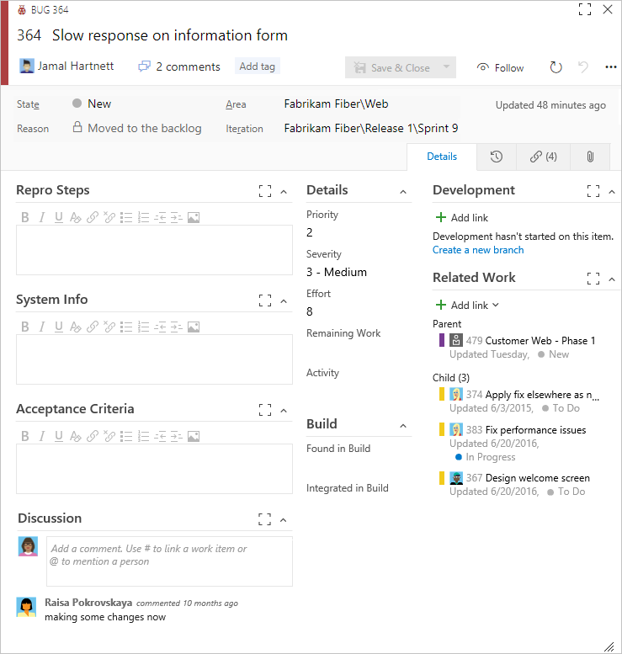

Figure 42 bug work item

### Fields specific to bugs

When defining a bug, use these fields to capture both the initial issue and ongoing discoveries made when triaging, investigating, fixing, and closing the bug.

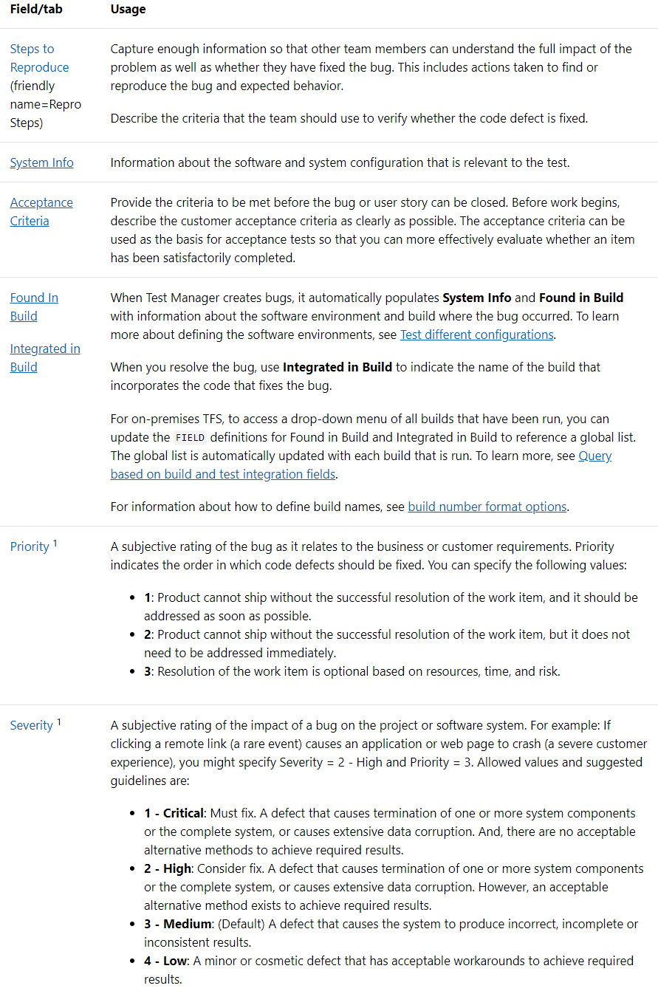

Notes:

1 To change the menu selection or picklist, see Customize the work tracking experience. The customization method depends on the process model used by your project.

For information about fields specific to the CMMI process, see Bugs, issues, and risks field reference. For information about all other fields, see Work item field index.

### Capture comments in the Discussion section

Use the Discussion section to add and review comments made about the work being performed.

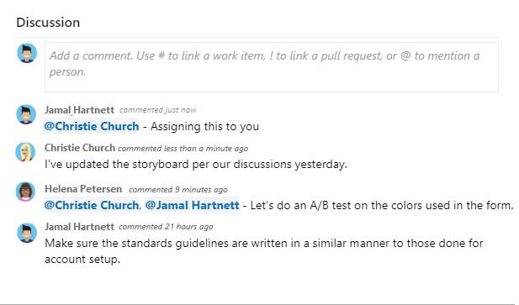

The rich text editor tool bar displays below the text entry area when you click your cursor within each text box that can be formatted.



Figure 43 Discussion

Mention someone, a group, work item, or pull request ( ,  , or )

Choose one of these icons —  ,  , or — to open a menu of recent entries you've made to mention someone, link to a work item, or link to a pull request. Or, you can simply type **@,** **#,** or **!** to open the same menu.

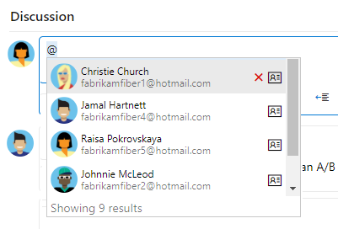

Figure 44 tagging someone into the discussion

Type a name, or enter a number and the menu list will filter to match your entry. Choose the entry you want to add. You can bring a group into the discussion by typing @ and the group name, such as a team or security group.

### Edit or delete a comment

If you need to edit or delete any of your discussion comments, choose  **Edit** or choose the  actions icon and then choose Delete.

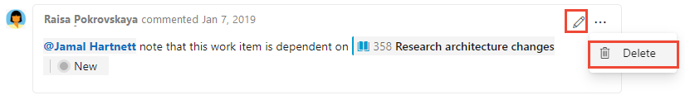

After updating the comment, choose Update. To delete the comment, you'll need to confirm that you want to delete it.

A full audit trail of all edited and deleted comments is maintained in the History tab on the work item form.

### Add a reaction to a comment

You can add one or more reactions to any comment. Choose a smiley icon at the upper-right corner of any comment or choose from the icons at the bottom of a comment next to any existing reactions. To remove your reaction, click the reaction on the bottom of your comment. The following shows an example of the experience of adding a reaction, as well as the display of reactions on a comment.

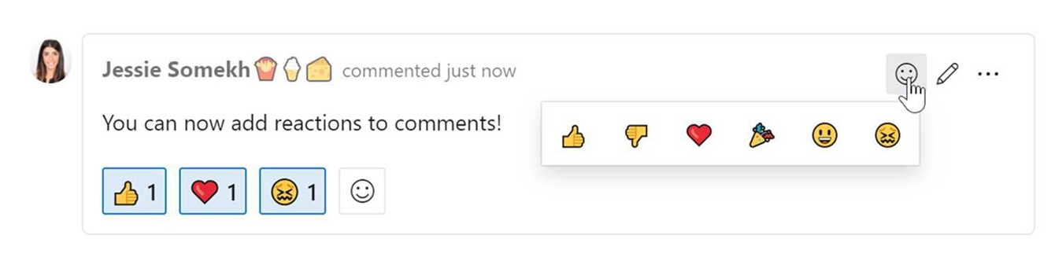

Figure 45 Add reaction to the discussion

### Triage bugs

Once you've started coding and testing, you'll want to hold periodic triage meetings to review and prioritize your bugs. How frequently you meet and for how long depends on your situation. Typically, the project owner runs the bug triage meetings, and team leads, business analysts and other stakeholders who can speak about specific project risks attend them.

The project owner can create or open a shared query for new and reopened bugs to generate a list of bugs to be triaged.

### Bug queries

Open a shared query or use the query editor to create useful bug queries, such as the following:

* Active bugs by priority (State <> Done or State <> Closed)
* In Progress bugs (State = Committed or State = Active)
* Bugs to fix for a target release (Tags Contains RTM)
* Recent bugs - bugs opened within the last 3 weeks (Created Date > @Today-21)

Once you have the queries of interest to your team, you can create status or trend charts that you can also add the chart to a dashboard.

### Triage mode in query results

From the query results page, you can quickly move up and down within the list of bug work items using the up and down arrows. As you review each bug, you can assign it, add details, or set priority.

### Assign bugs to a sprint

Once bugs have been triaged, it's time to assign them to a sprint to get fixed. By addressing a set of bugs to get fixed every sprint, your team can keep the total number of bugs to a reasonable size.

When bugs appear on the product backlog, you can assign bugs to sprints in the same way you do PBIs and user stories during your sprint planning sessions.

When bugs are treated as tasks, they're often automatically linked to a PBI or user story. So, assigning their parent PBI or user story to a sprint will assign the linked bugs to the same sprint as the parent PBI or user story during your sprint planning sessions.

Your team should consider fixing all bugs found during a sprint when testing a feature in development.

### Fix, resolve and close bugs (update status)

Bug fixes that involve more than a single section of code may require significant regression testing and may involve other team members. Record any conversations that relate to assessing the risk of bug fixes in the bug work item history.

### Bug workflow lifecycle

Once you fix a bug, you should update its workflow State. The following images illustrate the workflow lifecycle defined for the default bug workflow for the Agile processes.

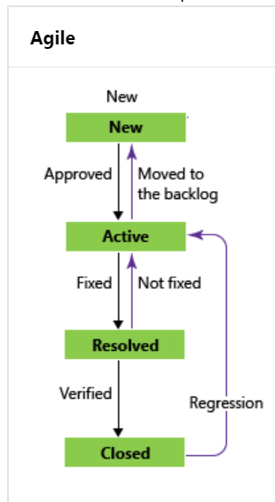

Figure 46 Bug workflow

For Agile, you first resolve the bug, indicating that the bug has been fixed. Typically, the person who created the bug then verifies the fix and updates the State from Resolved to Closed. If more work has been found after a bug has been resolved or closed, it can be reactivated by setting the State to Committed or Active.

### Verify a fix

To verify a fix, a developer or tester should attempt to reproduce the bug and look for additional unexpected behavior. If necessary, they should reactivate the bug.

When verifying a bug resolution, you may find that the bug was not completely fixed or you may disagree with the resolution. In this case, discuss the bug with the person who resolved it, come to an agreement, and possibly reactivate the bug. If you reactivate a bug, include the reasons for reactivating the bug in the bug description.

### Verify a bug, re-run tests defined for web apps

Choose the Verify option to re-run tests which identified the bug. You can invoke the Verify option from the bug work item form context menu to launch the relevant test case in the web runner. Perform your validation using the web runner and update the bug work item directly within the web runner.

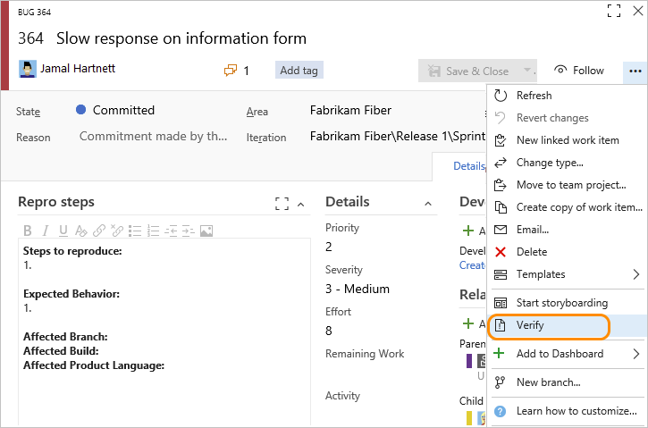

Figure 47 verify bug

### Close a bug

You close a bug once it's verified as fixed. However, you may also close a bug for one of these reasons:

* Deferred - deferring a fix until the next product release
* Duplicate - bug has already been reported, you can link each bug with the Duplicate/Duplicate of link type and close one of the bugs
* As Designed - feature works as designed
* Cannot Reproduce - tests prove that the bug can't be reproduced
* Obsolete - the bug's feature is no longer in the product
* Copied to Backlog - a PBI or user story has been opened to track the bug

It's always a good idea to describe any additional details for closing a bug in the Discussion field (new web form) or the History field (old web form) to avoid future confusion as to why the bug was closed.

### Monitor bug status, assignments, and trends

You can track the bug status, assignments, and trends using queries which you can then chart and add to a dashboard.

For example, here are two examples showing active bugs by priority trend and a snapshot of bugs by priority.

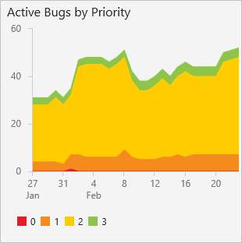 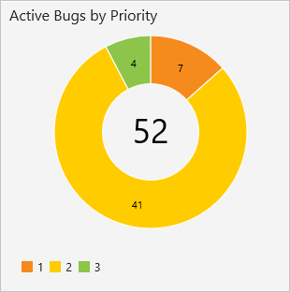

Figure 48 bug dashboards

## Manage issues or impediments

If you have known issues you want to track, you can do so by defining an impediment (Scrum) or issue (Agile or CMMI). Impediments and issues represent unplanned activities. Resolving them requires more work beyond what's tracked for actual requirements. Using the impediment work item type helps you track and manage these issues until you can resolve and close them.

Don't confuse impediments with bugs. You track impediments that may cause problems with delivering one or more requirements. For example, you may have to address feature ambiguity, personnel or resource issues, problems with environments, or other risks that impact scope, quality, or schedule. Other issues that deserve tracking are decisions that require several stakeholders or product teams to weigh in on.

### Prerequisites

* You must connect to a project. If you don't have a project yet, create one.
* You must be added to a project as a member of the Contributors or Project Administrators security group. To get added, Add users to a project or team.
* To add or modify work items, you must be granted Stakeholder access or higher. For details, see About access levels.
* To view or modify work items, you must have your View work items in this node and Edit work items in this node permissions set to Allow. By default, the Contributors group has this permission set. To learn more, see Set permissions and access for work tracking.
* To create new tags to add to work items, you must have Basic access or higher and have the project-level Create new tag definition permissions set to Allow. By default, the Contributors group has this permission set. Even if the permission is explicitly set for a Stakeholder, they won't have permission to add new tags, as they are prohibited through their access level.

### When to use issues versus tasks

You use issues or impediments to track items that may block work from getting done. In general, you link these items to user stories or other work items using a Related link type.

You define tasks when you want to create a checklist of tasks or if you use Scrum methods and track work using the Remaining Work field. By linking user stories, or other requirement work item types, to tasks using the Parent-Child link type, the tasks appear on the taskboard for each linked user story.

### Add an issue or impediment

Open **Boards**>**Work Items**, and choose the , and then select from the **New work item** menu of options.

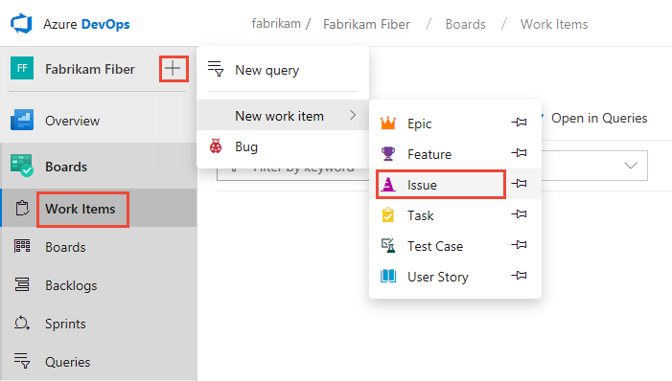

Figure 49 Add an issue or impediment

Choose the  pin icon to have it show up within the add drop down menu.

### Customize issues tracking

You can add fields, change the workflow, add custom rules, and add custom pages to the work item form of most work item types. You can also add custom work item types. For details, see Customize an inheritance process.

Impediments and issues don't appear on your backlog. Instead, you track them using queries. If you want them to appear on your backlog, or you want to track other work item types on your backlog, see Customize your backlogs or boards.

# Azure DevOps Git workflows in CollaBoard

Use version control to save your work and coordinate code changes across your team. Even if you're just a single developer, version control helps you stay organized as you fix bugs and develop new features. Version control keeps a history of your development so that you can review and even rollback to any version of your code with ease.

The steps in the following tutorials show how to perform common version controls tasks using the following version control workflow.

Version control workflow

Version control has a general workflow that most developers use when writing code and sharing it with the team.

These steps are:

1. Get a local copy of code if they don't have one yet.
2. Make changes to code to fix bugs or add new features.
3. Once the code is ready, make it available for review by your team.
4. Once the code is reviewed, merge it into the team's shared codebase.

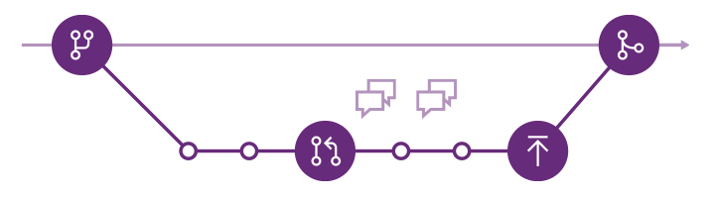

Figure 50 Azure DevOps Git workflow

## Git workflow

1. Create a branch for the changes you plan to make and give it a name, such as users/jamal/fix-bug-3214 or cool-feature-x. For more branching guidance, see Adopt a Git branching strategy
2. Commit changes to your branch. People often have multiple commits for a bug fix or feature.
3. Push your branch to the remote repository.
4. Create a pull request so other people can review your changes. To incorporate feedback, you might need to make more commits and push more changes.
5. Complete your pull request and resolve any merge conflicts from changes other people made after you created your branch.

## Create a branch

Git branches aren't much more than a small reference that keeps an exact history of commits, so they are very cheap to create. Committing changes to a branch will not affect other branches, and you can share branches with others without having to merge the changes into the main project. Create new branches to isolate changes for a feature or a bug fix from your master branch and other work.

Since the branches are lightweight, switching between branches is quick and easy. Git does not create multiple copies of your source when working with branches—it uses the history information stored in commits to recreate the files on a branch when you start working on it. Your Git workflow should create and use branches for managing features and bugfixes. The rest of the Git workflow, such as sharing code and reviewing code with pull requests all work through branches. Isolating work in branches makes it very simple to change what you are working on by simply changing your current branch.

### How are Git branches created?

Create branches using the branch command. Branch creates a reference in Git for the new branch and a pointer back to the parent commit so Git can keep a history of changes as you add commits to the branch. When you are working with a branch that someone else shared, Git keeps an upstream tracking relationship to associate the branch on the local repo with the corresponding branch on the remote repo. This makes it very simple to sync changes with others using push and pull.

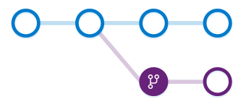

Figure 51 Azure DevOps Git branches

In this image, a new branch is created from the main branch. Work continues on both branches and commits are added to both branches.

Git always adds new commits to the current local branch. Check what branch you are working on before you commit so that you don't commit changes to the wrong branch. Swap between local branches using the checkout command. Git will change the files on your computer to match the latest commit on the checked out branch. When your work in the branch is ready to share with the rest of the team, you push the changes to update the remote branch.

A common mistake is to make some changes and commit them, realize you are on an incorrect branch, then checkout to the correct branch. Your most recent changes will no longer be on the filesystem since each branch has its own version of code. Git will bring the state of the files back to the last commit on the branch you swapped into, not the previous branch where you made your changes. You'll need to either cherry-pick the commits from the branch or merge the changes into the correct branch.

### Create a branch

**Visual Studio 2017 & 2019**

1. Open up Team Explorer and go to the Branches view.
2. Right-click the parent branch (usually master) to base your changes and choose New Local Branch From....
3. Supply a branch name in the required field and click Create Branch. Visual Studio automatically performs a checkout to the newly created branch.

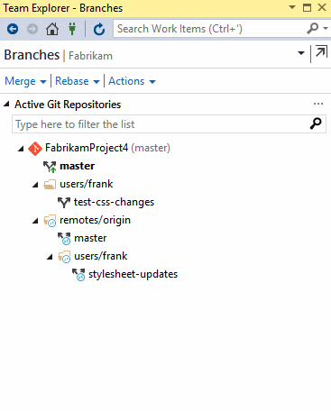

Figure 52 Visual Studio Git branches

**Command line**

Use the branch command to create the branch and checkout to swap to that branch.

git branch feature1

git checkout feature1

### Delete branch

**Visual Studio 2017 & 2019**

1. Open up Team Explorer and go to the Branches view.
2. Locate the branch you want to delete. Make sure that you aren't checked out to that branch, as you can't delete the branch you are currently working in.
3. Right-click the branch name and select Delete. If you have unpublished changes, Visual Studio will ask and make sure you want to delete the branch so you don't possibly lose work.

**Command line**

Delete a local branch using git branch -d while checked out to a different branch.

git branch -d

Deleting a remote branch requires use of the git push command using the --delete option.

git push origin –delete

### Use branches to manage development

Git keeps track of which branch you are working on and makes sure that when you checkout a branch your files match the most recent commit on the branch. Branches let you work with multiple versions of the source code in the same local Git repository at the same time. Tell Git which branch you want to work on with checkout, and Git takes care of setting the right file versions for that branch.

You shouldn't need more than one repo on your system when you use branches to isolate your work. Set up your development environment one time after you clone, and then use Git branches to swap between feature work and bug fixing.

## Commit changes

Git does not automatically snapshot your code as you make edits to files in your repo. You must tell Git exactly which changes you want to add to the next snapshot by staging those changes. After staging your changes, create a commit to save the snapshot to your repo.

### How Git tracks changes

Git tracks file changes in your repo as you work, and separates the files in your repo into three categories:

Unmodified files - These files haven't changed since your last commit.

Modified files - These files have changes since your last commit, but you haven't yet staged for the next commit.

Staged files - These files have changes that will be added to the next commit.

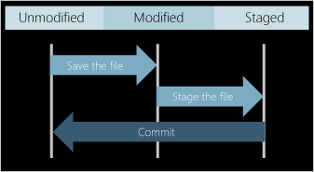

Figure 53 How Git tracks changes

When you create a commit, only the staged changes and unchanged files are used for the snapshot. Changes to unstaged but modified files are kept, but the commit uses the unmodified version from the previous commit in its snapshot.

Commits are created in your local Git repository, so you don't have to worry about your changes being perfect. Continue to create commits as you work, pushing your changes to the team when they are ready to share.

### What's in a commit

Commits include the following information:

* A snapshot of the files saved in the commit. Git snapshots the contents of all files in your repo at the time of the commit—this makes switching versions very fast and helps Git merge changes.
* A reference to the parent commit(s). Commits with multiple parents occur when branches are merged together.
* A short and to the point message describing the changes in the commit. You enter this message when you create the commit.

Git uses the references between commits along with the file snapshots to maintain a complete record of development in your repo.

### Stage your changes

Git does not automatically add changed files to the snapshot when you create a commit. You must first stage your changes to let Git know which updates you want to add to the next commit. Staging lets you to selectively add files to a commit while excluding changes made in other files.

Ignore temp files, logs, and other files that might change on your local machine but you don't want to add to version control.

**Visual Studio 2015 (Update 2) and 2017**

Visual Studio keeps track of file changes to your project as you do your work. When you are ready to stage changes, open up the **Changes** view in Team Explorer.

Stage individual file changes by right-clicking a file in the **Change** view and selecting **Stage**. Staging a change creates a **Staged Changes** section in Team Explorer. Only changes in the **Staged Changes** section are added to the next commit.

Stage multiple files or folders by selecting them then right-clicking and choosing Stage or by dragging and dropping files from the Changes list into the Staged Changes list.

Ignore files by right-clicking and selecting Ignore this local item or Ignore this extension. This adds an entry to the .gitignore file in your local repo. If the ignored file was added to your repo in an earlier commit, ignoring the file will not remove it from the Changes list. See excluding and ignoring files section for more information on how to ignore files already tracked by Git.

### Create a commit

Open the Changes view in Team Explorer.

Enter a commit message describing your changes and select Commit Staged to create a new commit that includes the changes listed in the Staged Changes section.

Skip staging files if you just want to commit all changes listed by entering a commit message and selecting Commit All when you have no staged changes.

When you commit in Visual Studio you can push the commit and sync the branch with a remote repository. These options are available in the drop-down on the Commit button.

### Update your last commit

Amend your last commit to correct small errors without making a new commit.

**Visual Studio 2015 (Update 2) and 2017**

1. Open the Changes view in Team Explorer and stage your updated changes. You can amend just the commit message by leaving the staged changes empty.
2. Enter the updated commit message and select Amend Previous Commit from the Actions drop-down.

## Push your branch

Share changes made in commits and branches using the push command. Push your branches to the remote repository, where Git takes the commits and adds them to an existing branch on the remote or creates a new branch with the same commits as your local branch.

Git makes sure that pushed changes are consistent with the remote branch so others can pull your commits and merge them into their own local copy of the branch. Pushed branches that have finished work are reviewed and merged into the main branch of the your repo through a pull request.

**Visual Studio 2015 (Update 2) and 2017**

1. Open up the Synchronization view in Team Explorer by selecting the Home icon and choosing Sync. You can also navigate to the Synchronization view from the Changes view by choosing Sync immediately after making a commit.
2. Select Push to share your commit with the remote repository. f this is your first push to the repository you'll see the following message in place of the outgoing commits list: The current branch does not track a remote branch. Push your changes to a new branch on the origin remote and set the upstream branch. Select Push to push your changes to a new branch on the remote repository and set the upstream branch. The next time you push changes you'll see the list of commits.

### Resolve merge conflicts before pushing

If there are conflicts between your local commits on the commits on the remote branch, you must first resolve these conflicts before you can push your changes. You should pull the changes from others first, resolve the conflicts and commit the changes, then re-attempt the push.

## Create a pull request

Git's workflow uses branches to isolate work until you're ready to merge the changes into your default branch, such as master. The pull request is the collaborative process that lets the rest of the team discuss changes in a branch and agree to merge them once everyone approves. Use pull requests to get early feedback from others on work in progress, even if you're not ready to merge the changes into another branch.

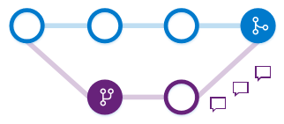

Figure 54 pull request

In this image, the purple branch is merged into the blue branch through a pull request. The changes are discussed by reviewers in the pull request before the code is merged. When you complete the pull request, there is a merge commit (seen here as the filled blue commit) where the changes in the purple branch are now merged in the blue branch.

### Create a pull request

To create a pull request in Azure Repos:

1. Push your local branch.
2. Create a pull request for the branch. You can do this in the Code view on the web from either the Pull Requests tab or the Files tab.

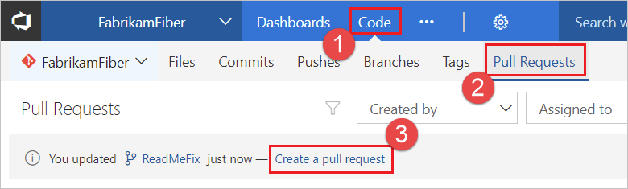

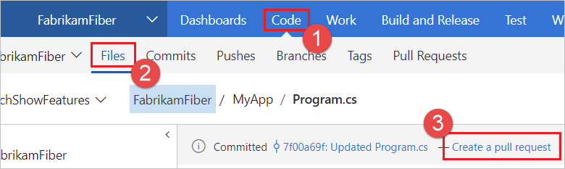

Figure 55 Update your last commit

You can also initiate a pull request from Visual Studio. Select the Pull Requests view when connected to your Project.

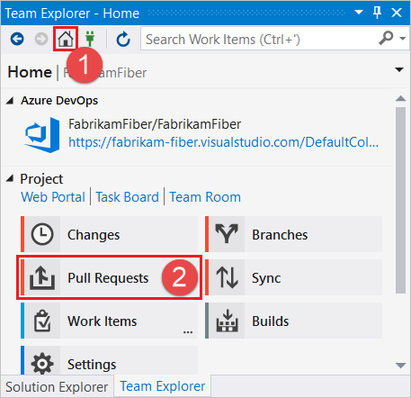

Figure 56 Visual Studio. Select the Pull Requests

From the Pull Requests view you can view pull requests opened by you, assigned to you, and you can create new pull requests. Select New Pull Request to open up a web browser where you can create the new pull request in the Azure DevOps Services web portal for your current branch.

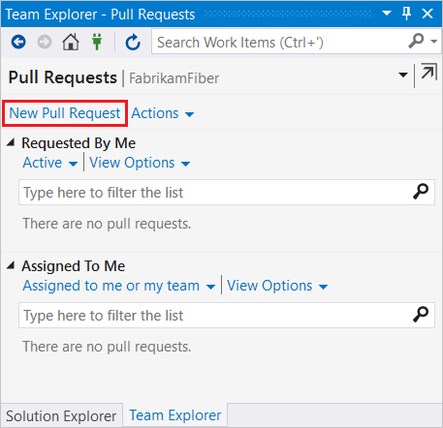

Figure 57 creating a new pull request from visual studio

1. Create the pull request. You should give a clear title for the pull request that describes the changes in the branch. In the description field give a clear explanation of how the changes are implemented along with any resources that might help reviewers understand the changes. You can include VSTS work items and hyperlinks to allow others to have as much context as possible when reviewing your changes. Add any team member who you would like to review the changes.

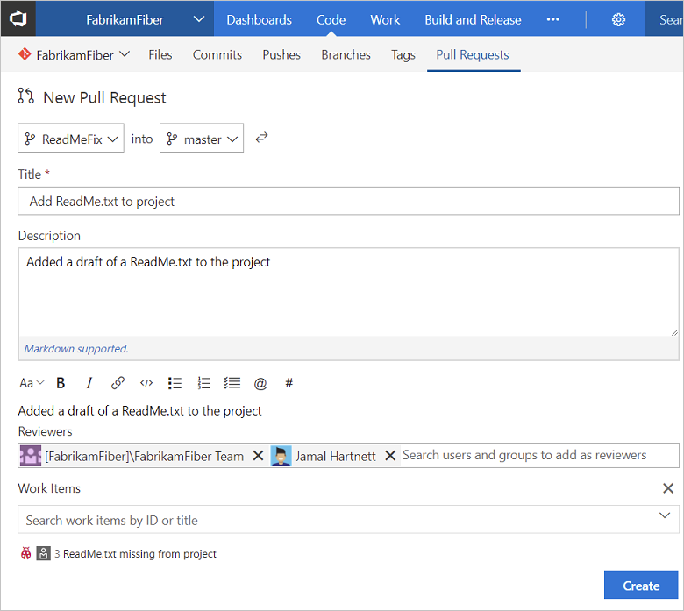

Figure 58 including VSTS work items

### Who reviews the pull request?

When you create the pull request, you can add others who need to review your changes. You can add users and groups to the pull request after it is created if the scope of the review needs to expand. You can also associate the pull request with a task in Azure Boards to let others working with the task know changes are ready for review.

### How does the code review work?

Pull request reviewers will see the proposed updates to the branch in the form of file differences between the two branches. Reviewers can add comments on any of the changes and include notifications for other team members to answer a question or give other feedback. You can make changes and push commits to resolve issues brought up in the feedback and these changes are immediately reflected in the pull request.

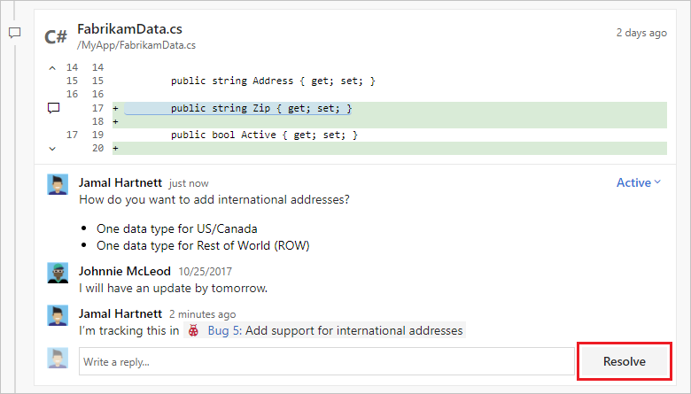

Figure 59 PR code review

If the changes need much more development to complete, you can abandon the pull request. You can later open up a new pull request to revisit the changes and link to the conversations that took place in the abandoned pull request.

You can also open up a pull request on a very early version of your code to ask for feedback from others, even if the code isn't ready to merge yet. Once you get the team's feedback, you can keep the pull request open to continue the conversation or abandon the pull request until your code is ready to be shared again.

### Complete a pull request

Complete your pull request after the reviewers approve of the changes by selecting Complete in the upper right of the pull request view.

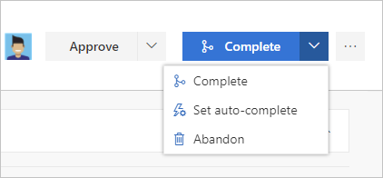

Figure 60 completing PR

* **Complete**: Complete the pull request now and merge the changes to the target branch.
* **Set auto-complete**: If you have branch policies, you can choose Set auto-complete to configure the pull request to close once all branch policies are met. For more information on auto-complete (and reasons why you might not see this option), see Complete automatically.
* **Abandon**: Choose Abandon to close the pull request without merging the changes.

Enter the message used for the merge commit and update the pull request description as needed in the dialog that follows

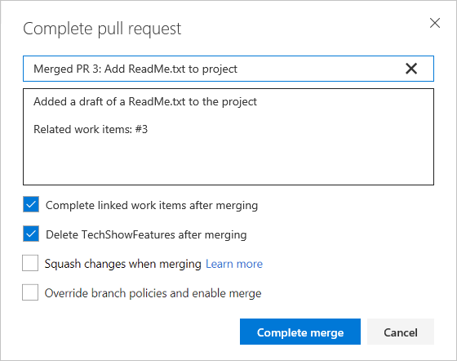

Figure 61 completing PR

* Check **Complete linked work items after merging** to complete any linked work items.
* Check **Delete** <branch name> **after merging** to delete the source branch from the pull request. Git retains the commit history in the master branch after the pull request is complete, so unless you plan on doing more work in the branch, it is safe to remove.
* Check **Squash changes when merging** to squash merge your pull request.
* Check **Override branch policies and enable merge** to force merge even if all branch policies haven't been satisfied. This option is only available if you have Exempt from policy enforcement permissions.

### What happens when a pull request is merged?

You must resolve any merge conflicts between the pull request branch and the target branch. Git adds a new commit (the merge commit) to the end of the master branch. This merge commit links the earlier history of both the master branch and the commits for the branch that was merged as part of the pull request.

# Continuous Integration tools

The Development Team needs a toolset in order to allow easily communicating to each other and a CI infrastructure to facilitate the integration and delivery task. In the CollaBoard project we provide those tools, but the most important issue is to have a clear workflow and guidelines to be able to work together. Not all team members are obligated to use the same Integrated Development Environment (IDE), but all the team must share the same guidelines, metrics and branching workflow and deliver the artifacts to the same repository. The listing below shows the list of tools installed and prepared to use for the CollaBoard project which will be briefly described in the following sections.

**Project Management and Agile**

Agile software development methods with planning, tracking and reporting for shorter release cycles and full visibility into your software development process. Manage projects with GitHub. And, use Azure Boards to:

* Define, assign, and track work items.
* Manage backlogs.
* Create custom dashboards to track progress.
* Get advanced analytics and reporting.

**Source Code Management**

Azure DevOps

**Quality Assurance**

Visual Studio Code Analysys

OWASP Dependency Check

Microsoft Dependency Traker

NuGet Dependency Checker

**Automation Server**

Azure DevOps Pipelinees

**Artifact Repository**

Azure DevOps

**Automated testing**

Azure Pipeline testing tasks and Visual Studio Test projects

The main objective is to build a useful and agile workflow to interact with, easing the modules integration and organizational activities

## Source Code Management

### Azure DevOps

To manage git repositories, share and collaborate with GitHub. Create a reliable code workflow for your team with:

* Pull requests and code reviews.
* Issue tracking.
* Continuous integration tools—including apps from the GitHub Marketplace.

## Quality Assurance

### Visual Studio Code Analysis

When you configure code analysis in Visual Studio, you can choose from a list of built-in rule sets. A rule set is a grouping of code analysis rules that identify targeted issues and specific conditions for that project. For example, you can apply a rule set that's designed to scan code for publicly available APIs. You can also apply a rule set that includes all the available rules.

You can customize a rule set by adding or deleting rules or by changing rule severities to appear as either warnings or errors in the Error List. Customized rule sets can fulfill a need for your particular development environment. When you customize a rule set, the ruleset editor provides search and filtering tools to help you in the process.

Rulesets are available for managed code analysis, legacy analysis of managed code, and C++ code analysis.

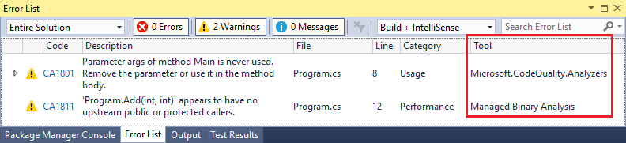

Figure 62 VS Code analysis differences between violations from code analyzers and legacy analysis in the Error List

### OWASP Dependency-Check

Dependency-Check is a software composition analysis utility that identifies project dependencies and checks if there are any known, publicly disclosed, vulnerabilities. Currently, Java and .NET are supported; additional experimental support has been added for Ruby, Node.js, Python, and limited support for C/C++ build systems (autoconf and cmake). The tool can be part of a solution to the OWASP Top 10 2017 A9-Using Components with Known Vulnerabilities previously known as OWASP Top 10 2013 A9-Using Components with Known Vulnerabilities.

The OWASP Dependency-Check Azure DevOps Extension enables the following features in an Azure Build Pipeline:

Software composition analysis runs against package references during each build

Export vulnerability data to HTML, JSON, XML, CSV, JUnit formatted reports

Download vulnerability reports from the build's artifacts

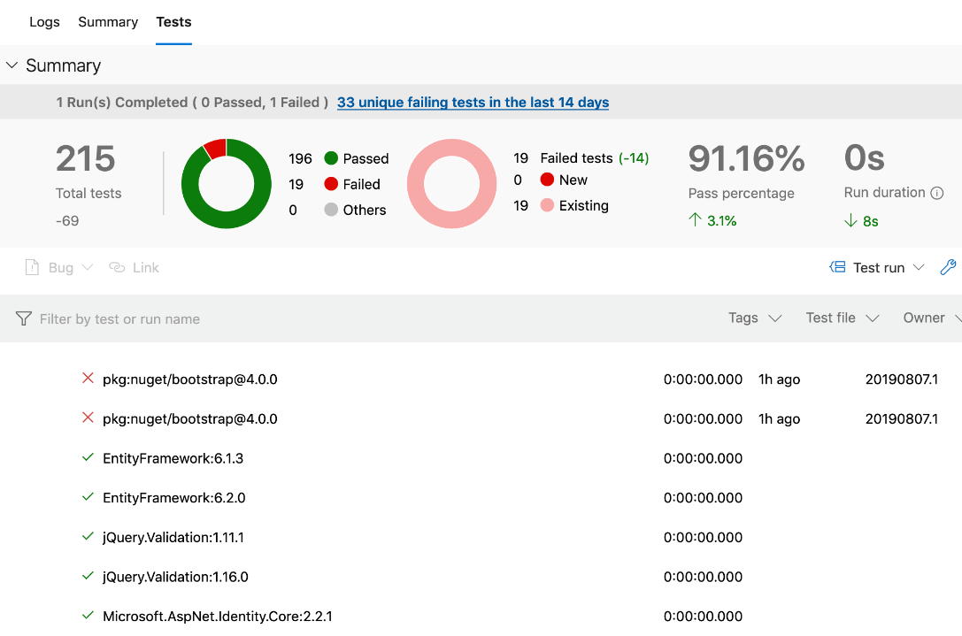

Figure 63 Owasp Dependency-Check report

### Dependency Tracker

Dependency Tracker allows planning and tracking dependencies across multiple areas. It helps provide visibility into the health of the dependencies and gives an overall status at a quick glance.

Consuming Dependencies is work the selected area path is dependent on other area paths to complete. It shows all work items that have a predecessor link for work items in this area path.

Producing Dependencies is work the selected area path is doing where other area paths are dependent on. It shows all work items that have a successor link to items in this area path.

Interacting with the Report

Select ‘Dependencies Consuming’ to see what work your area is dependent on or select ‘Dependencies Producing’ to see what work you owe other areas.

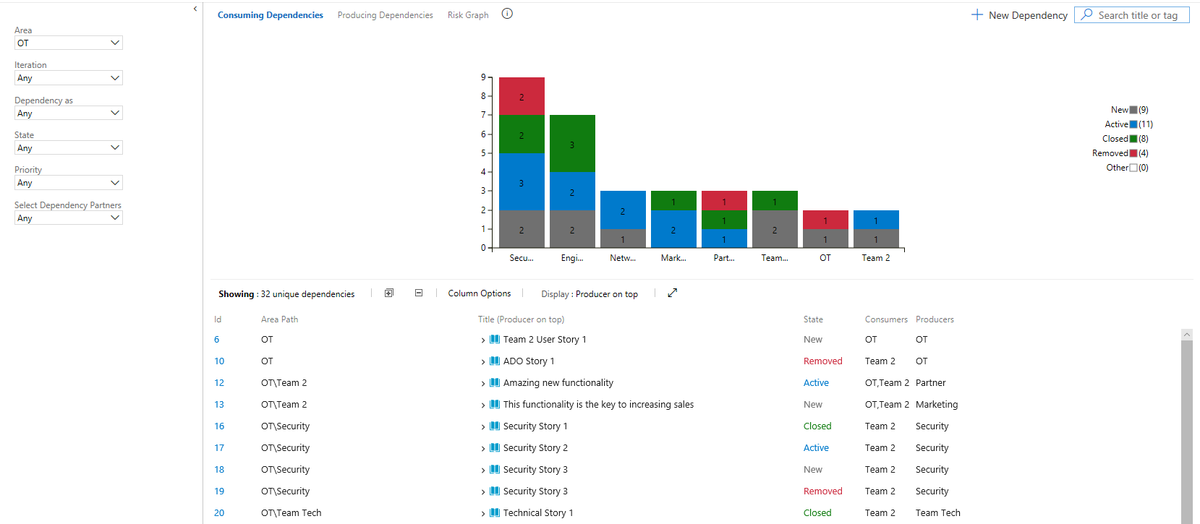

Figure 64 Dependency tracker results

### NuGet Dependency Checker

Simple Tool for checking NuGet Dependencies and publish a report as build artifact. The results will be added to a new build tab and can be saved as build artifact. (no dashboard widget yet, but i will work on it!).

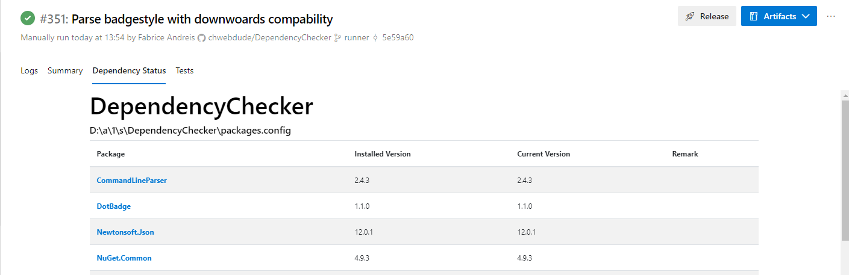

Figure 65 NuGet Dependency Checker results

## Automation Server

### Azure DevOps Pipelinees

Visual Studio provides the Azure Resource Group project for creating templates and deploying them to your Azure subscription. You can integrate this project with Azure Pipelines for continuous integration and continuous deployment (CI/CD).

There are two ways to deploy templates with Azure Pipelines:

* Add task that runs an Azure PowerShell script. This option has the advantage of providing consistency throughout the development life cycle because you use the same script that is included in the Visual Studio project (Deploy-AzureResourceGroup.ps1). The script stages artifacts from your project to a storage account that Resource Manager can access. Artifacts are items in your project such as linked templates, scripts, and application binaries. Then, the script deploys the template.
* Add tasks to copy and deploy tasks. This option offers a convenient alternative to the project script. You configure two tasks in the pipeline. One task stages the artifacts and the other task deploys the template.

## Artifact Repository

### DevOps tools on Azure

With end-to-end solutions on Azure, teams can implement DevOps practices in each of the application lifecycle phases: plan, develop, deliver, and operate. These DevOps technologies, combined with people and processes, enable teams to continually provide value to customers.

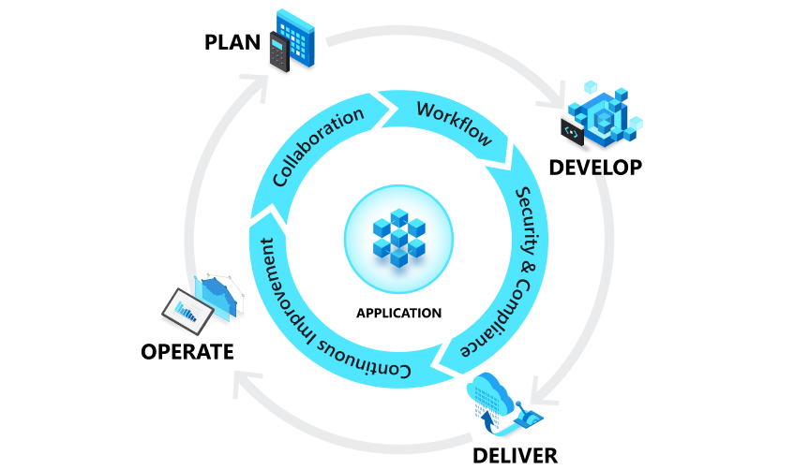

Figure 66 DevOps and the application lifecycle

Plan

Empower teams to manage their work with agility and full visibility across products and projects. Define, track, and lay out work with Kanban boards, backlogs custom dashboards and reporting capabilities using Azure Boards. Keep development efforts transparent and on schedule with GitHub. Explore analytics with visuals and turn data into insights with Power BI.

Develop

Code faster and smarter with Visual Studio and Visual Studio Code. Share code and collaborate with like-minded developers with GitHub. Automate testing and practice continuous integration in the cloud with Azure Pipelines, create automatic workflows from idea to production with GitHub Actions, and even bring your Jenkins workloads to the Azure. Provision environments for developers in minutes with Azure DevTest Labs.

Deliver

Deploy your application to any Azure service automatically and with full control to continuously deliver value to customers. Define and spin up multiple cloud environments with Azure Resource Manager or HashiCorp Terraform, then create continuous delivery pipelines into these environments using Azure Pipelines or tools such as Jenkins and Spinnaker.

Operate

Implement full stack monitoring, get actionable alerts, and gain insights from logs and telemetry with Azure Monitor. Manage your cloud environment with Azure Automation and tools such as Ansible, Chef, or Puppet.

Keep provisioned infrastructure and applications in compliance with Azure Blueprints or Chef Automate. Used with Azure Security Center, you’ll limit threat exposure as well as find and remediate vulnerabilities quickly.

## Automated testing

### Azure Pipeline testing tasks

Use this task in a build or release pipeline to run unit and functional tests (Selenium, Appium, Coded UI test, and more) using the Visual Studio Test Runner. Other than MSTest-based tests, test frameworks that have a Visual Studio test adapter, such as xUnit, NUnit, Chutzpah, can also be executed.

Tests that target the .NET core framework can be executed by specifying the appropriate target framework value.

### Testing tools in Visual Studio

Visual Studio testing tools can help you and your team develop and sustain high standards of code excellence.

**Test Explorer**

The Test Explorer window helps developers create, manage, and run unit tests. You can use the Microsoft unit test framework or one of several third-party and open source frameworks.

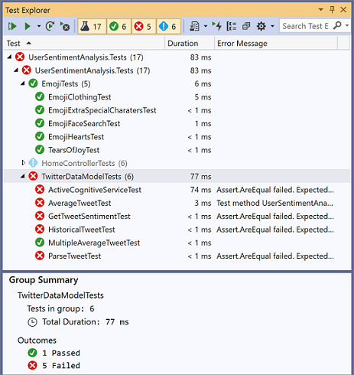

Figure 67 team explorer testing

Visual Studio is also extensible and opens the door for third-party unit testing adapters such as NUnit and xUnit.net. In addition, the code clone capability goes hand-in-hand with delivering high-quality software by helping you identify blocks of semantically similar code that may be candidates for common bug fixes or refactoring.

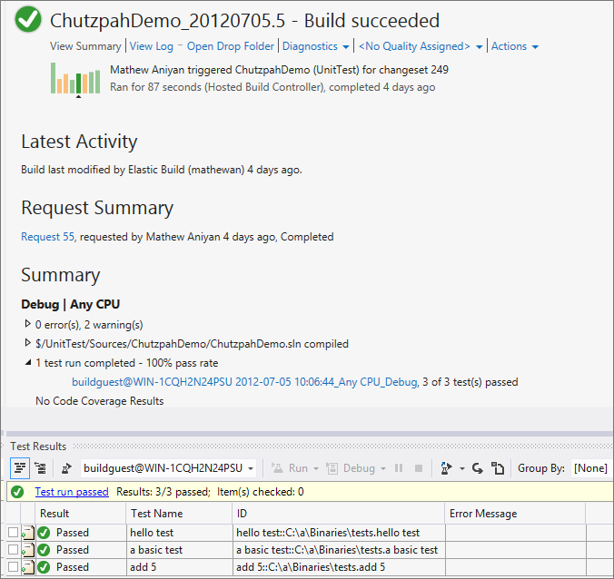

Figure 68 team explorer test results

**Live Unit Testing**

Live Unit Testing automatically runs unit tests in the background, and graphically displays code coverage and test results in the Visual Studio code editor.

**IntelliTest**

IntelliTest automatically generates unit tests and test data for your managed code. IntelliTest improves coverage and dramatically reduces the effort to create and maintain unit tests for new or existing code.

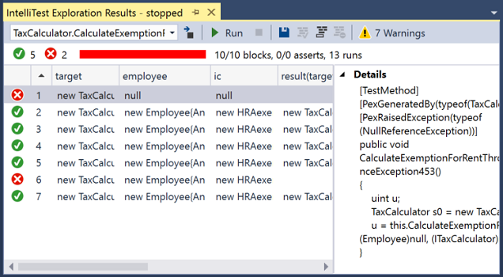

Figure 69 c team explorer test list

**Code coverage**

Code coverage determines what proportion of your project's code is actually being tested by coded tests such as unit tests. To guard effectively against bugs, your tests should exercise or "cover" a large proportion of your code.

Code coverage analysis can be applied to both managed and unmanaged (native) code.

Code coverage is an option when you run test methods using Test Explorer. The results table shows the percentage of the code that was run in each assembly, class, and method. In addition, the source editor shows you which code has been tested.

* Use code coverage to determine how much code is being tested
* Unit testing, code coverage and code clone analysis with Visual Studio (Lab)
* Customize code coverage analysis

**Microsoft Fakes**

Microsoft Fakes help you isolate the code you're testing by replacing other parts of the application with stubs or shims.

**User interface testing with Coded UI and Selenium**

Coded UI tests provide a way to create fully automated tests to validate the functionality and behavior of your application’s user interface. They can automate UI testing across a variety of technologies, including XAML-based UWP apps, browser apps, and SharePoint apps.

Whether you choose best-of-breed Coded UI Tests or generic browser-based UI testing with Selenium, Visual Studio provides all the tools you need.

# Continuous Integration Continuous Delivery in Collaboard

Azure DevOps Projects presents a simplified experience where you can bring your existing code and Git repo or choose a sample application to create a continuous integration (CI) and continuous delivery (CD) pipeline to Azure.

You will:

* Use DevOps Projects to create a CI/CD pipeline
* Configure access to your GitHub repo and choose a framework
* Configure Azure DevOps and an Azure subscription
* Commit changes to GitHub and automatically deploy them to Azure
* Examine the Azure Pipelines CI/CD pipeline
* Configure Azure Application Insights monitoring
* Clean up resources

This scenario provides architecture and design guidance for building a continuous integration (CI) and continuous deployment (CD) pipeline. In this example, the CI/CD pipeline deploys a two-tier .NET web application to the Azure App Service.

Migrating to modern CI/CD processes provides many benefits for application builds, deployments, testing, and monitoring. By using Azure DevOps along with other services such as App Service, organizations can focus on the development of their apps rather than the management of the supporting infrastructure.

Relevant use cases

Consider Azure DevOps and CI/CD processes for:

Accelerating application development and development lifecycles.

Building quality and consistency into an automated build and release process

Increasing application stability and uptime.

## Architecture

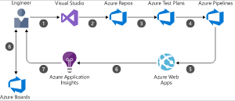

Figure 70 CI/CD architecture

The data flows through the scenario as follows:

1. A developer changes application source code.
2. Application code including the web.config file is committed to the source code repository in Azure Repos.
3. Continuous integration triggers application build and unit tests using Azure Test Plans.
4. Continuous deployment within Azure Pipelines triggers an automated deployment of application artifacts with environment-specific configuration values.
5. The artifacts are deployed to Azure App Service.
6. Azure Application Insights collects and analyzes health, performance, and usage data.
7. Developers monitor and manage health, performance, and usage information.
8. Backlog information is used to prioritize new features and bug fixes using Azure Boards.

## Prerequisites

* An Azure subscription. You can get one free through Visual Studio Dev Essentials.
* Access to a GitHub or external Git repo that contains .NET, Java, PHP, Node, Python, or static web code.

## Sign in to the Azure portal

Azure DevOps Projects creates a CI/CD pipeline in Azure Pipelines. You can create a new Azure DevOps organization or use an existing organization. Azure DevOps Projects also creates Azure resources in the Azure subscription of your choice.

1. Sign in to the Azure portal.
2. In the left pane, select **New**.
3. In the search box, type **DevOps Projects**, and then select **Create**.

The DevOps Projects dashboard

1. Select **Bring your own code**, and then select **Next**.

## Configure access to your GitHub repo and choose a framework

1. Select either GitHub or an external Git repo, and then select your repo and the branch that contains your application.
2. Select your web framework, and then select Next.

.NET framework

The application framework, which you chose previously, dictates the type of Azure service deployment target that's available here.

1. Select the target service, and then select Next.

## Configure Azure DevOps and an Azure subscription

1. Create a new Azure DevOps organization or select an existing organization.

a. Enter a name for your project in Azure DevOps.

b. Select your Azure subscription and location, enter a name for your application, and then select Done.

After a few minutes, the DevOps Projects dashboard is displayed in the Azure portal. A sample application is set up in a repo in your Azure DevOps organization, a build is executed, and your application is deployed to Azure. This dashboard provides visibility into your GitHub code repo, the CI/CD pipeline, and your application in Azure.

1. Select Browse to view your running application.

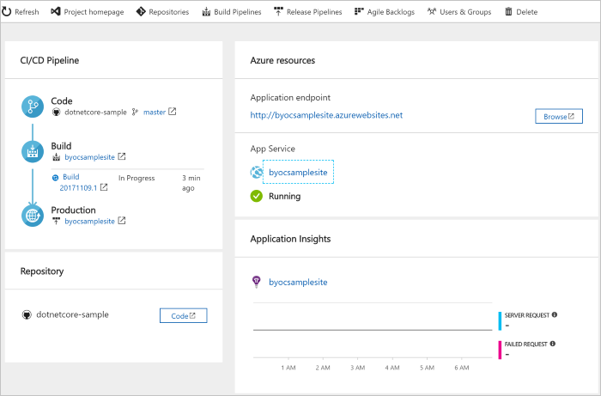

Figure 71 Configuring Azure DevOps subscriptions

Azure DevOps Projects automatically configures a CI build and release trigger. Your code remains in your GitHub repo or another external repo.

## Commit changes to GitHub and automatically deploy them to Azure

You're now ready to collaborate with a team on your app by using a CI/CD process that automatically deploys your latest work to your website. Each change to the GitHub repo starts a build in Azure DevOps, and a CD pipeline executes a deployment to Azure.

1. Make a change to your application, and then commit the change to your GitHub repo.

After a few moments, a build starts in Azure Pipelines. You can monitor the build status in the DevOps Projects dashboard, or you can monitor it in the browser with your Azure DevOps organization.

1. After the build is completed, refresh your application to verify your changes.

## Examine the Azure Pipelines CI/CD pipeline

Azure DevOps Projects automatically configures a CI/CD pipeline in Azure Pipelines. Explore and customize the pipeline as needed. To familiarize yourself with the build and release pipelines, do the following:

1. At the top of the DevOps Projects dashboard, select **Build pipelines**.

A browser tab displays the build pipeline for your new project.

1. Point to the Status field, and then select the ellipsis (...).

A menu displays several options, such as queueing a new build, pausing a build, and editing the build pipeline.

1. Select **Edit**.
2. In this pane, you can examine the various tasks for your build pipeline.

The build performs various tasks, such as fetching sources from the Git repo, restoring dependencies, and publishing outputs used for deployments.

1. At the top of the build pipeline, select the build pipeline name.
2. Change the name of your build pipeline to something more descriptive, select **Save & queue**, and then select **Save**.
3. Under your build pipeline name, select History.

You see an audit trail of your recent changes for the build. Azure DevOps keeps track of any changes made to the build pipeline, and it allows you to compare versions.

1. Select **Triggers**.

Azure DevOps Projects automatically creates a CI trigger, and every commit to the repo starts a new build. Optionally, you can choose to include or exclude branches from the CI process.

1. Select **Retention**.

Depending on your scenario, you can specify policies to keep or remove a certain number of builds.

1. Select **Build and Release**, and then select **Releases**.

Azure DevOps Projects creates a release pipeline to manage deployments to Azure.

1. Select the ellipsis (...) next to your release pipeline, and then select Edit.

The release pipeline contains a pipeline, which defines the release process.

1. Under Artifacts, select Drop.

The build pipeline you examined in the previous steps produces the output that's used for the artifact.

1. Next to the Drop icon, select Continuous deployment trigger.

This release pipeline has an enabled CD trigger, which executes a deployment every time there is a new build artifact available. Optionally, you can disable the trigger so that your deployments require manual execution.

1. At the left, select Tasks.

Tasks are the activities that your deployment process executes. In this example, a task was created to deploy to the Azure App service.

1. At the right, select View releases to display a history of releases.
2. Select the ellipsis (...) next to a release, and then select Open.

There are several menus to explore, such as a release summary, associated work items, and tests.

1. Select Commits.

This view shows code commits that are associated with this deployment.

1. Select Logs.

The logs contain useful information about the deployment process. You can view them both during and after deployments.

## Configure Azure Application Insights monitoring

With Azure Application insights, you can easily monitor your application's performance and usage. Azure DevOps Projects automatically configures an Application Insights resource for your application. You can further configure various alerts and monitoring capabilities as needed.

1. In the Azure portal, go to the DevOps Projects dashboard.
2. At the lower right, select the **Application Insights** link for your app.

The Application Insights pane opens. This view contains usage, performance, and availability monitoring information for your app.

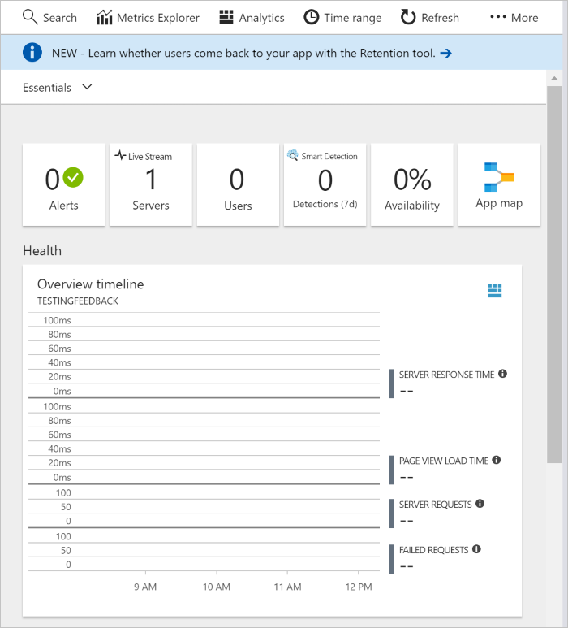

Figure 72 Application insight overview

1. Select Time range, and then select Last hour. To filter the results, select Update.

You can now view all activity from the last 60 minutes. To exit the time range, select x.

1. Select Alerts, and then select Add metric alert.
2. Enter a name for the alert.
3. In the Source Alter on drop-down list, select your App Service resource.
4. In the Metric drop-down list, examine the various alert metrics.

The default alert is for a server response time greater than 1 second. You can easily configure a variety of alerts to improve the monitoring capabilities of your app.

1. Select the Notify via Email owners, contributors, and readers check box.

Optionally, you can perform additional actions when an alert is displayed by executing an Azure logic app.

1. Select OK to create the alert.

After a few moments, the alert appears as active on the dashboard.

1. Exit the Alerts area, and go back to the Application Insights pane.
2. Select Availability, and then select Add test.
3. Enter a test name, and then select Create.

A simple ping test is created to verify the availability of your application. After a few minutes, test results are available, and the Application Insights dashboard displays an availability status.

## Clean up resources

When they are no longer needed, you can delete the Azure App service and related resources that you created in this tutorial. To do so, use the Delete functionality on the DevOps Projects dashboard.

# State of the art CI/CD in CollaBoard

Out of all the guidelines and documentation in the following chapter, we will describe the actual state of the art of CI/CD in CollaBoard both for Server/Client and on cloud and on-premises environment.

## CI/CD CollaBoard Server

Our CI/CD process starts from the definition of two main branches:

* Master
* Dev/vNext

Dev/vNext contains all the source code that is deployed on the test environment, basically it contains the next version that will be published in production including new features and bug fix.

Master contains the code that is actually running on our production environment.

The branches are highlighted in the picture below.

With such approach, we are able to perform actions on all the important environment anytime and we can keep tracks of the code deployed, such approach is very important in case of dealing with bugs on specified environment.

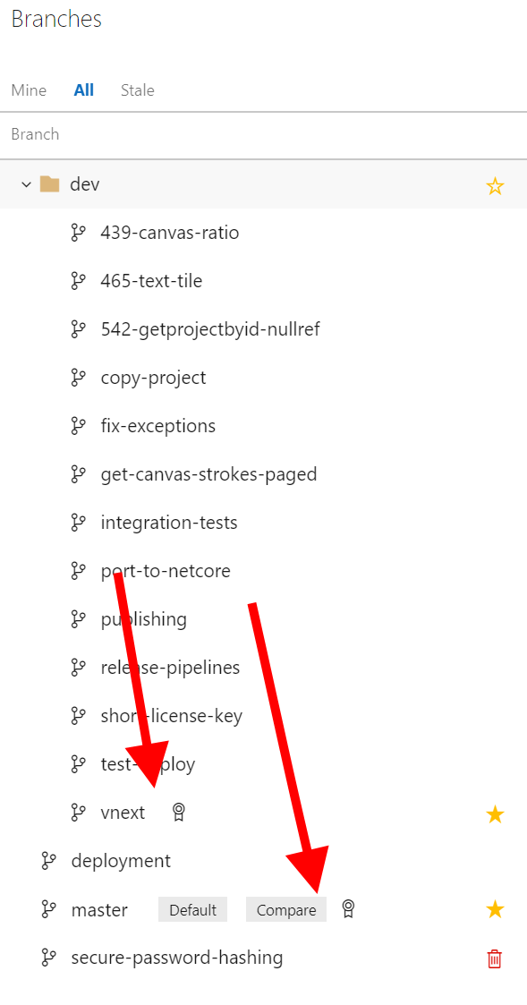

Figure 73 CollaBoard Server Git branches

In order to keep our code bug free and also ti fight against any regression bug new development can cause, we have a long saeires of integration testes (see picture below) that are performed every time code changes are added to the dev branch.

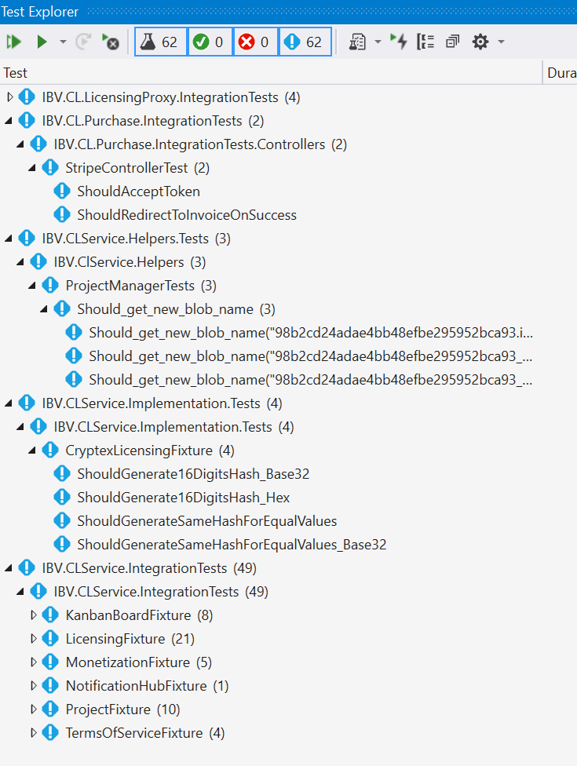

Figure 74 CollaBoard Server Integration tests

For CollaBoard services we have two build pipelines, one for the Dev branch and one for the Prod branch, as you can see in the picuture below.

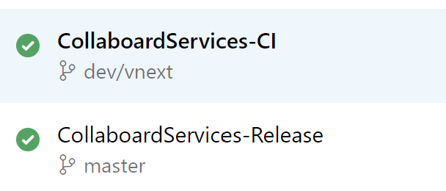

Figure 75 CollaBoard Server build pipelines

## CI/CD CollaBoard Server / Test environment

The build pipeline for the dev branch is automatically triggered when a pull request is accepted on the dev branch. In the picture below you can see the trigger that will automatically start the build pipeline

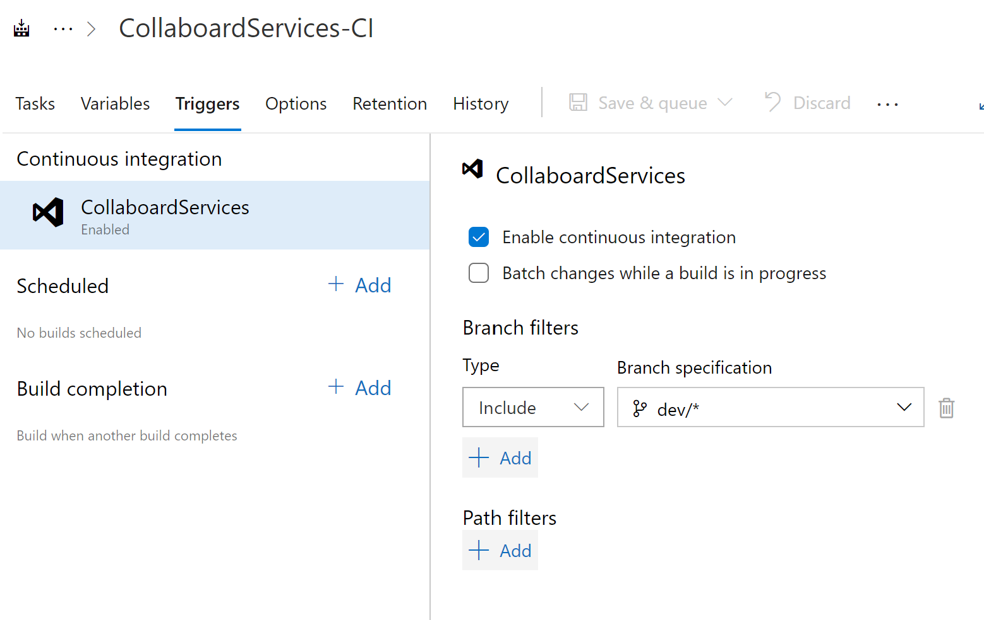

Figure 76 CollaBoard continuous integration trigger for dev

The dev build pipeline performs all the needed tasks in order to build the application for debugging (creating debug assemblies).

It also automatically performs all the integration tests (point one on the picture below) detailed above on this paragraph.

It publishes the binaries, that will later be used by the release pipeline, (point two in the picture below)

It performs all the dependency checks (point three on the picture below) and report are produced.

As the last task also a report about the used NuGet packages is produced

To get an insight about the dependency check too and the NuGet package check tools please refer to the appropriate chapter in this document.

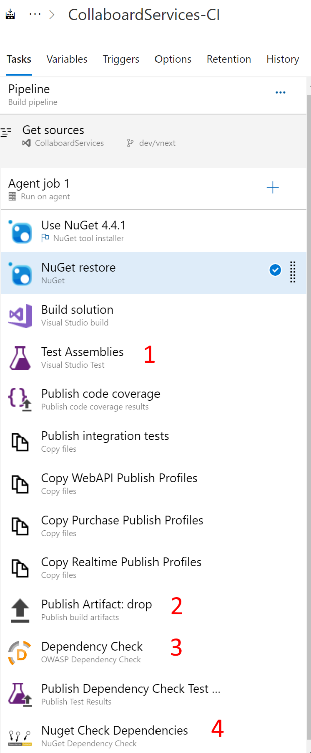

Figure 77 CollaBoard Server Dev build tasks

Once the build is completed, produced assemblies are automatically deployed on our test environment, and as you can see in the picture below, all the integration tests that needs to be performend once the new endpoints are deployed they starts.

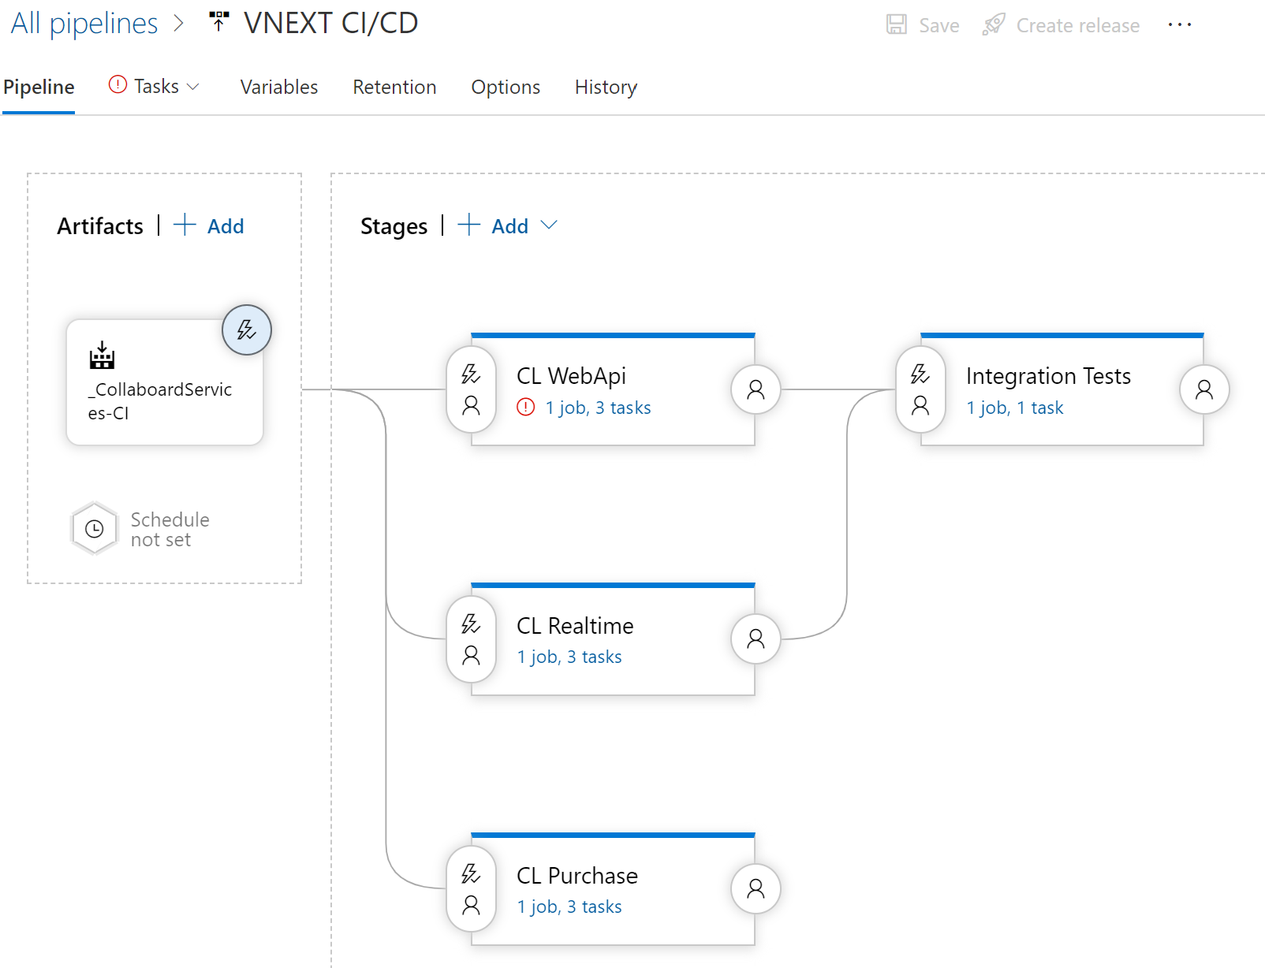

Figure 78 CollaBoard Server Dev release tasks

On the picture below you can see the trigger that automatically starts the release on the test environment once the dev build is completed

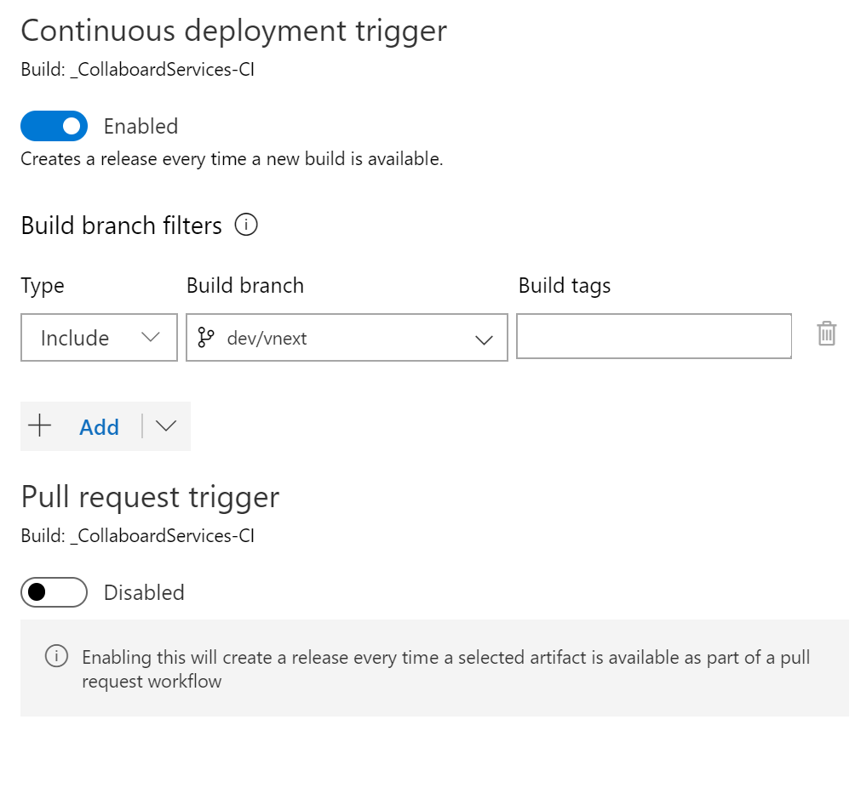

Figure 79 CollaBoard Server Dev release trigger

## CI/CD CollaBoard Server / Release environment environment

For the release build we need to have more control on when to publish changes to our production server, for this reason we don’t have a trigger that automatically starts the process.

If it is true that the process needs to be manually started, once is started everything is automatic.

All the needed components are build in release mode, in the picture below you can see the build tasks

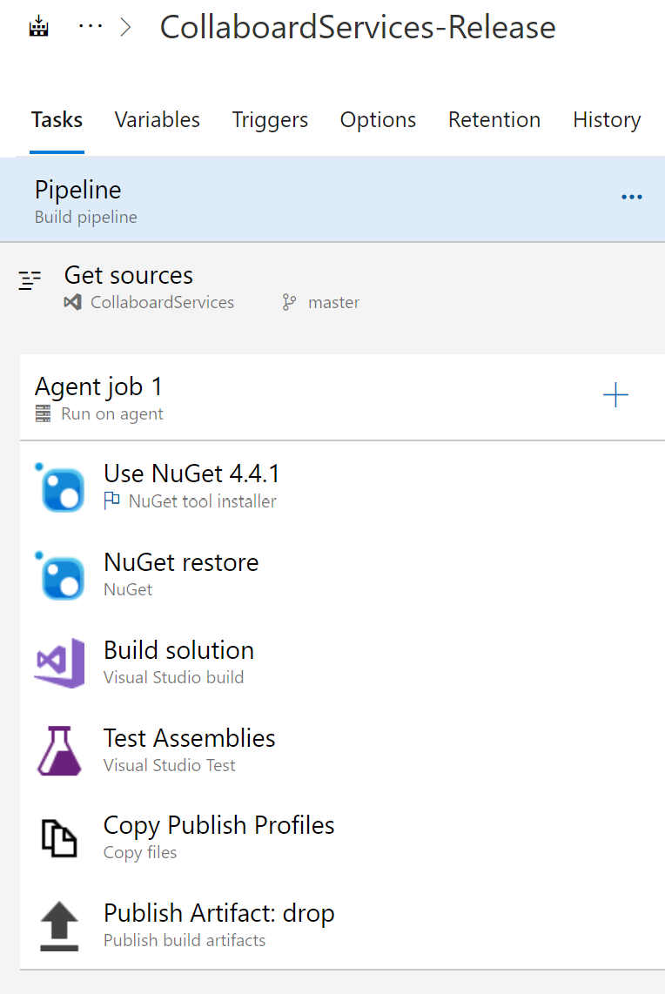

Figure 80 CollaBoard Server release build tasks

Once the assemblies bits are correctly compiled by the build pipeline, the release trigger automatically starts the publishing process on all our three azure environments:

* East US
* East Asia
* West Europe

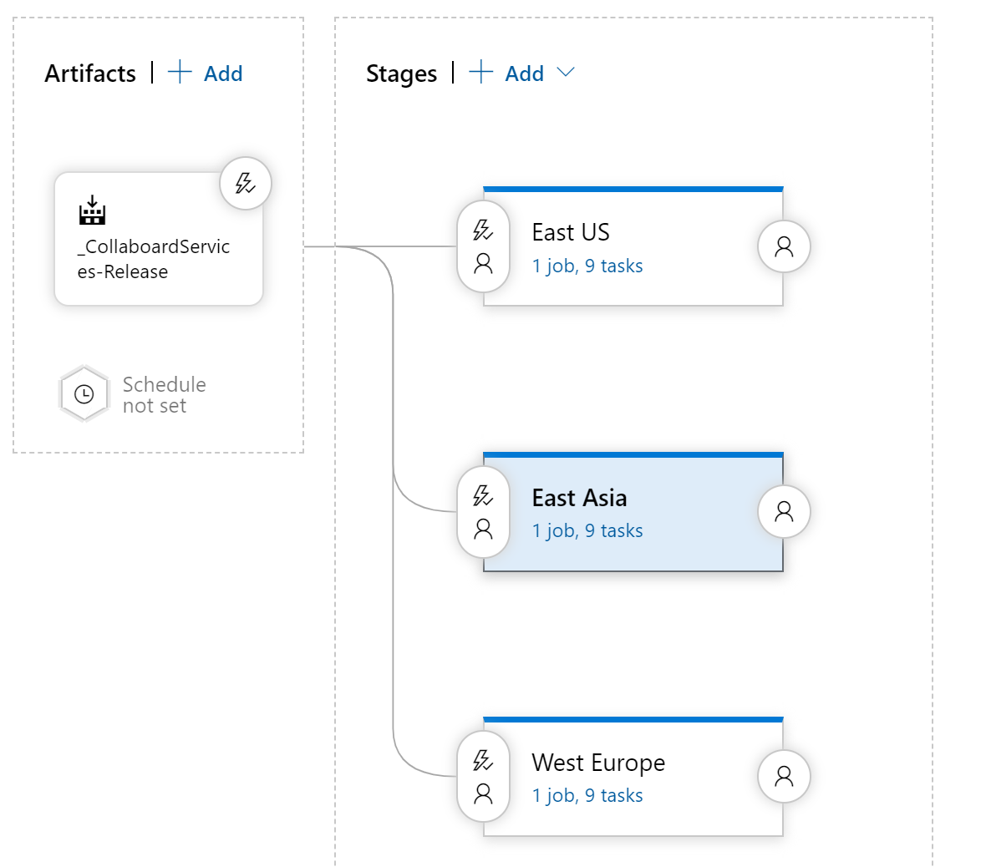

Figure 81 CollaBoard Server Prod release tasks

Each release process consists of automatically publishing all the needed components in order to allow our services to run. In the picture below you can see a detail of all the task needed to publish CollaBoard server on one production environment, East US represented in the picture below; identical tasks are performed for the remaining two environments

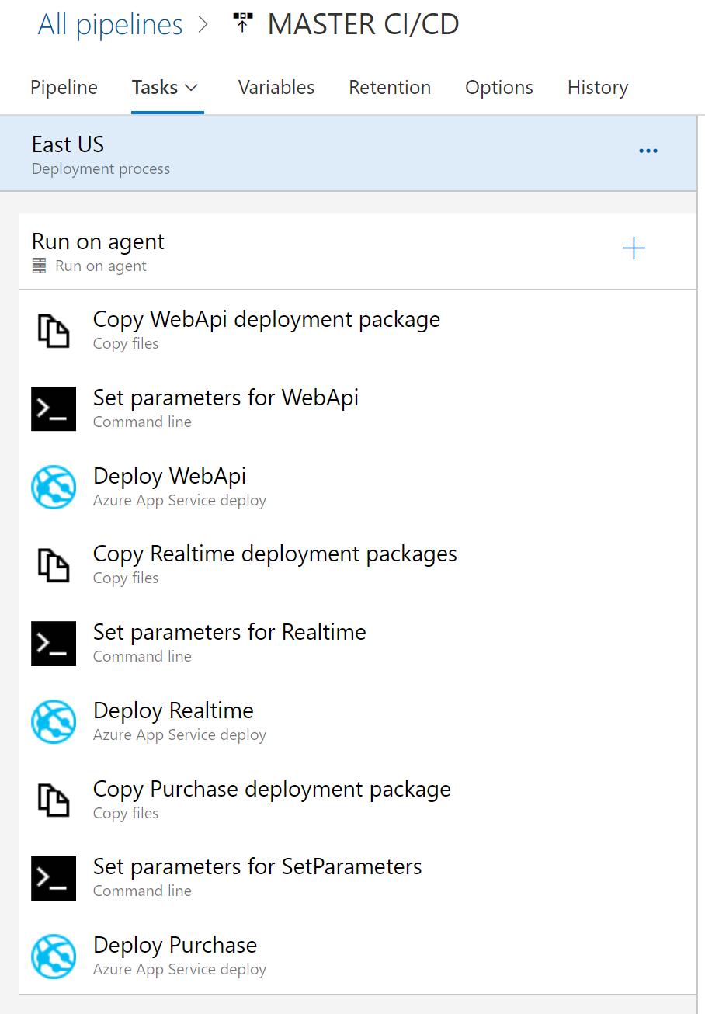

Figure 82 CollaBoard Server Prod release tasks East US environment

## CI/CD CollaBoard Server / On-premises environment

For the deployment of the on-premises environment, the process is still manual.

Once the build is saved as artifact the DevOps engineer can copy the assemblies and manually update the needed

For insight on how to install the server solution on-premises please refer to the installation manual.

* The on-premise release is an area when we need to improve the on-premises environment. In two main ways:
* Creating an automatic installer application that the DevOps engineer will be able to start like the installation of any other windows application
* By creating DevOps connectors able to automatically publish on the on-premises environment as a release task

## CI/CD CollaBoard Client

Our CI/CD process starts from the definition of two main branches:

* Master
* Dev/vNext

Dev/vNext contains all the source code that is deployed on the test environment; basically it contains the next version that will be published in production including new features and bug fix.

Master contains the code that is actually running on our production environment.

The branches are highlighted in the picture below.

With such approach, we are able to perform actions on all the important environment anytime and we can keep tracks of the code deployed, such approach is very important in case of dealing with bugs on the specified environment.

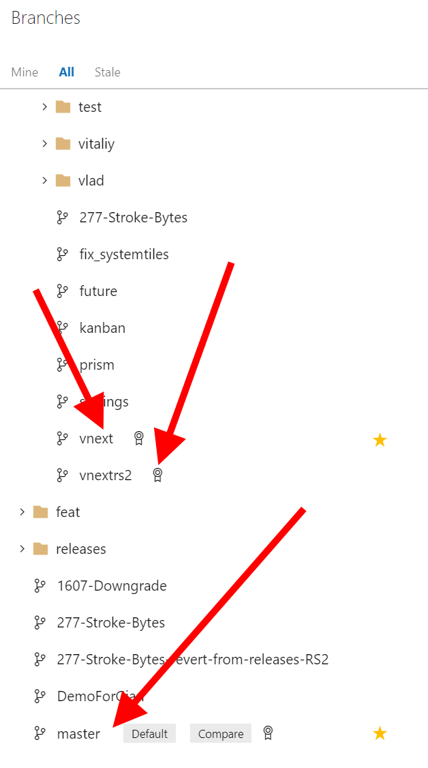

Figure 83 CollaBoard Client Git branches

In order to keep our code bug free and also ti fight against any regression bug new development can cause, we have a long series of integration tests (see picture below) that are performed every time code changes are added to the dev branch

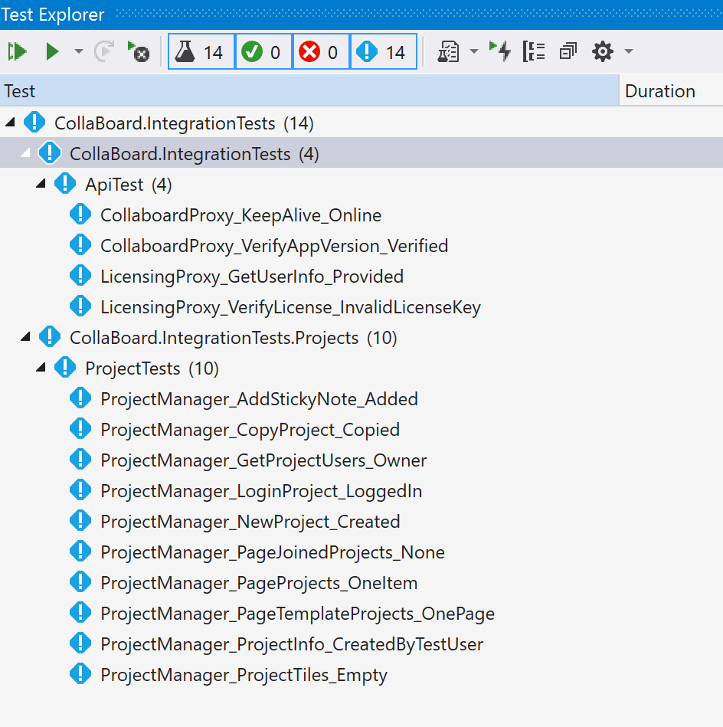

Figure 84 CollaBoard Client Integration tests

## CI/CD CollaBoard Client On-Premises

Due to keeping compatibility with the SurfaceHub where it isn’t possible to store permanent app data we have a custom build for each of our on-premises customer. The picture below reports some of the build pipeline we have for our customer.

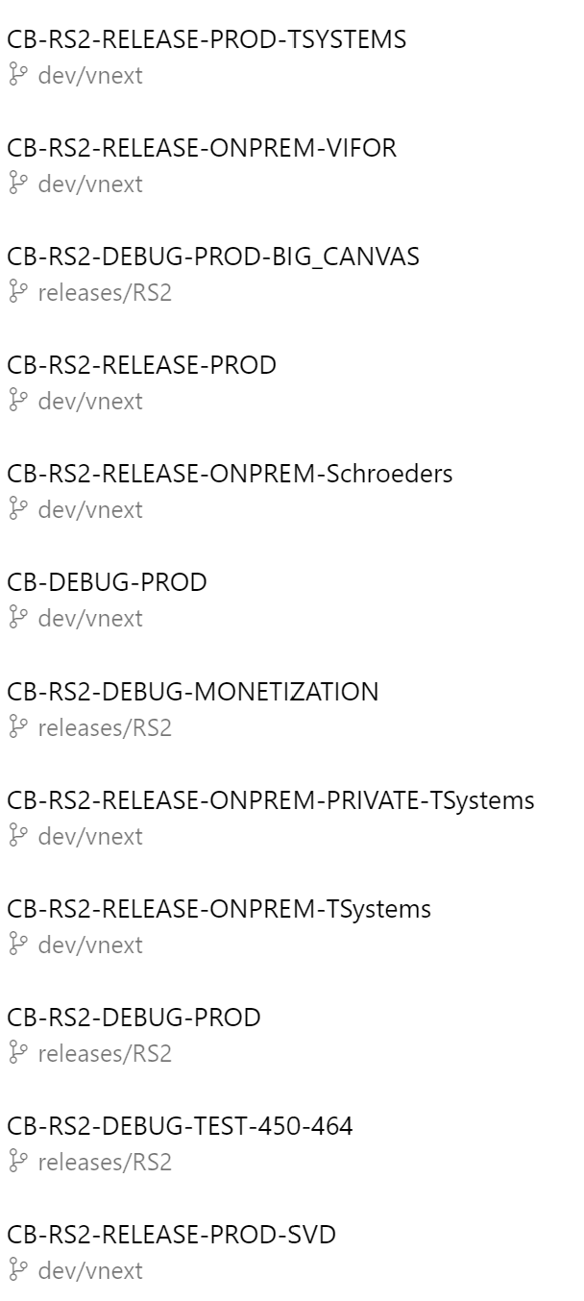

Figure 85 CollaBoard Client build for on-premises customers

Once the build is completed the artifact is manually downloaded and made available for the on-premise client to download and install

## CI/CD CollaBoard Client Test Environment

We also have a custom build pipeline when the pp is built for testers.

For this pipeline we had to opt for the YAML layout because we are integrating UWP integration tests in the pipeline and the only way to integrate them is to have a YAML pipeline.

At the end of the day there is no difference with a standard pipeline, the artifact is created and then manually uploaded to the Windows Store for tester to go their test process.

This build, though is automatically triggered when a PR is accepter on dev/vNextRS2

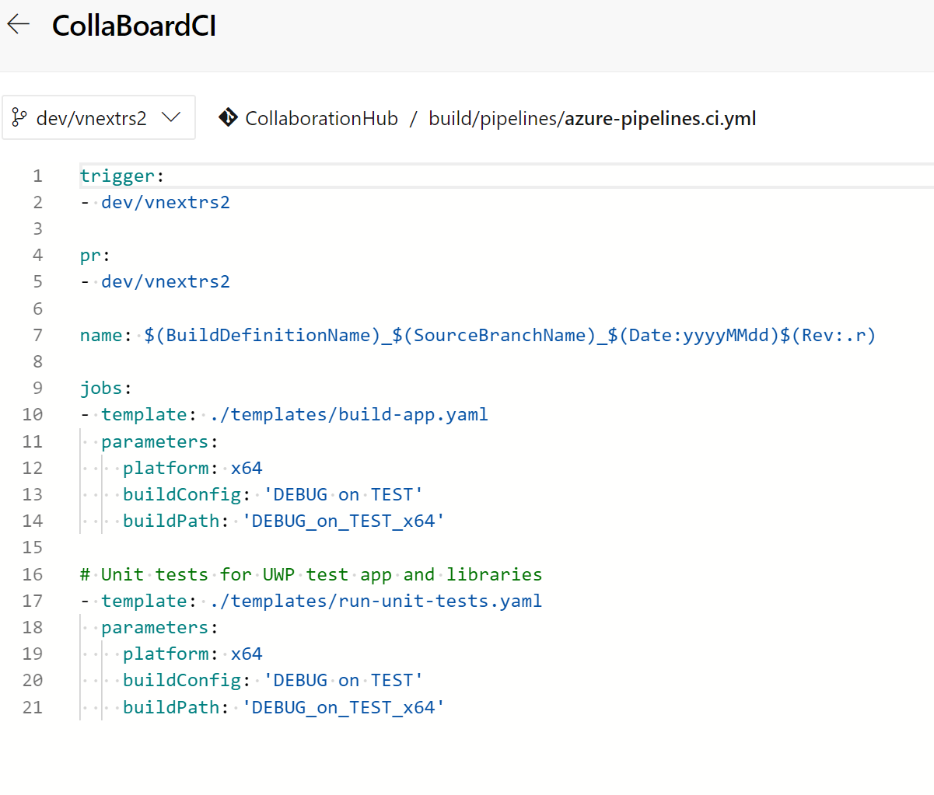

Figure 86 CollaBoard Client test build YAML layout

## CI/CD CollaBoard Client Release Environment

For the release build pipeline the were no need to have a YAML layout so we opted for the standard way.

Assemblies are built and saved as artifact. When the DevOps engineer need to publish for the store the update is manual.

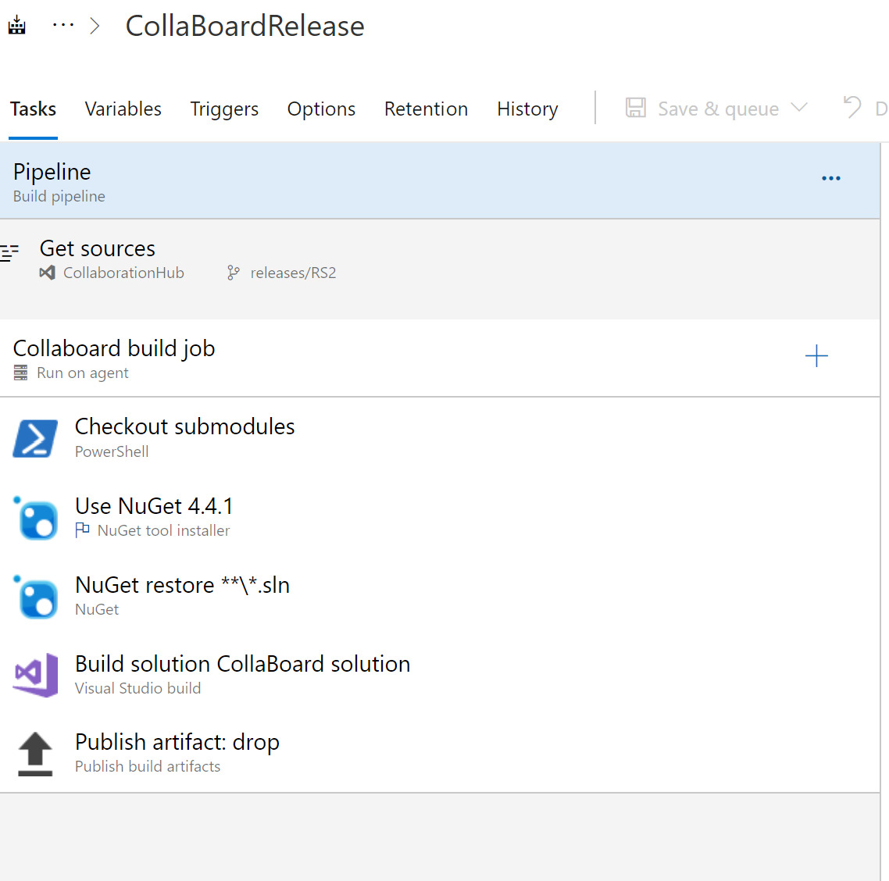

Figure 87 CollaBoard Client release build

There is a way to automate the Windows Store publishing process but at the moment we are not able to use it because we use an MSA account to log into the Windows Store and there is no way to link an Azure Active Directory account to the MSA user we are using.

We are investigating together with Microsoft a workaround for this issue that will alou us to have both Test and Release environment automatically updated.

# Continuous security validation to CI/CD for Software Quality Assurance

DevOps practices are allowing businesses to stay ahead of the competition by delivering new features faster than ever before. As the frequency of production deployments increases, this business agility cannot come at the expense of security. With continuous delivery, how do you ensure your applications are secure and stay secure? How can you find and fix security issues early in the process? This begins with practices commonly referred to as DevSecOps. DevSecOps incorporates the security team and their capabilities into your DevOps practices making security a responsibility of everyone on the team. This article will walk you through how to help ensure your application is secure by adding continuous security validation to your CI/CD pipeline.

Security needs to shift from an afterthought to being evaluated at every step of the process. Securing applications is a continuous process that encompasses secure infrastructure, designing an architecture with layered security, continuous security validation, and monitoring for attacks.

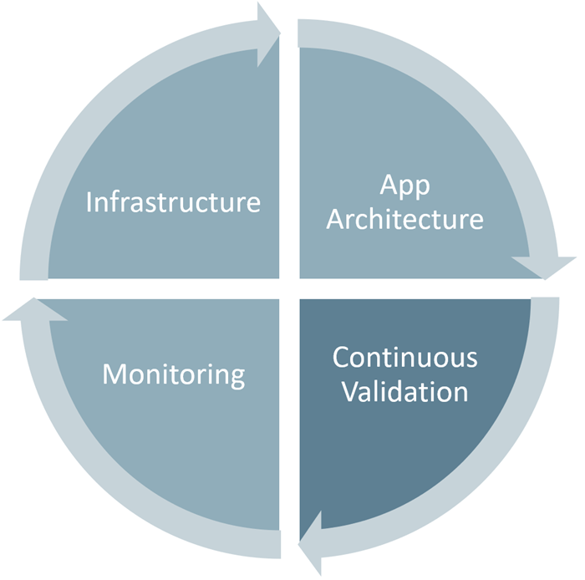

Figure 88 Continuous security validation to CI/CD for Software Quality Assurance

Continuous security validation should be added at each step from development through production to help ensure the application is always secure. The goal of this approach is to switch the conversation with the security team from approving each release to approving the CI/CD process and having the ability to monitor and audit the process at any time. When building greenfield applications, the diagram below highlights the key validation points in the CI/CD pipeline. Depending on your platform and where your application is at in its lifecycle, you may need to consider implementing the tools gradually. Especially if your product is mature and you haven't previously run any security validation against your site or application.

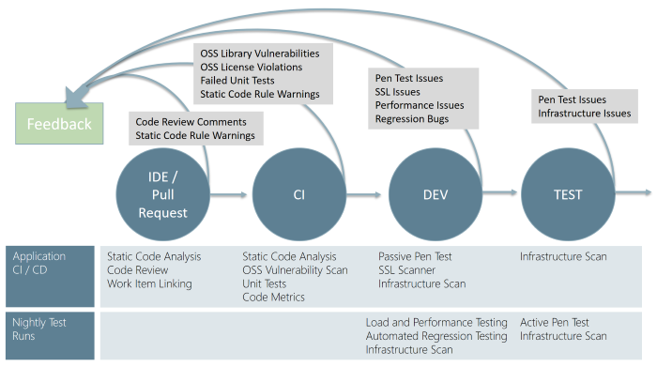

Figure 89 Continuous security workflow

## IDE / Pull Request

Validation in the CI/CD begins before the developer commits his or her code. Static code analysis tools in the IDE provide the first line of defense to help ensure that security vulnerabilities are not introduced into the CI/CD process. The process for committing code into a central repository should have controls to help prevent security vulnerabilities from being introduced. Using Git source control in Azure DevOps with branch policies provides a gated commit experience that can provide this validation. By enabling branch policies on the shared branch, a pull request is required to initiate the merge process and ensure that all defined controls are being executed. The pull request should require a code review, which is the one manual but important check for identifying new issues being introduced into your code. Along with this manual check, commits should be linked to work items for auditing why the code change was made and require a continuous integration (CI) build process to succeed before the push can be completed.

CI (Continuous Integration)

The CI build should be executed as part of the pull request (PR-CI) process discussed above and once the merge is complete. Typically, the primary difference between the two runs is that the PR-CI process doesn't need to do any of the packaging/staging that is done in the CI build. These CI builds should run static code analysis tests to ensure that the code is following all rules for both maintenance and security. Several tools can be used for this.

* Visual Studio Code Analysis and the Roslyn Security Analyzers
* Checkmarx - A Static Application Security Testing (SAST) tool
* BinSkim - A binary static analysis tool that provides security and correctness results for Windows portable executables
* Other 3rd party tools

Many of the tools seamlessly integrate into the Azure Pipelines build process. Visit the VSTS Marketplace for more information on the integration capabilities of these tools.

In addition to code quality being verified with the CI build, two other tedious or ignored validations are scanning 3rd party packages for vulnerabilities and OSS license usage. Often when we ask about 3rd party package vulnerabilities and the licenses, the response is fear or uncertainty. Those organizations that are trying to manage 3rd party packages vulnerabilities and/or OSS licenses, explain that their process for doing so is tedious and manual. Fortunately, there are a couple of tools by WhiteSource Software that can make this identification process almost instantaneous. The tool runs through each build and reports all of the vulnerabilities and the licenses of the 3rd party packages. WhiteSource Bolt is a new option, which includes a 6-month license with your Visual Studio Subscription. Bolt provides a report of these items but doesn't include the advanced management and alerting capabilities that the full product offers. With new vulnerabilities being regularly discovered, your build reports could change even though your code doesn't. Checkmarx includes a similar WhiteSource Bolt integration so there could be some overlap between the two tools. See, Manage your open source usage and security as reported by your CI/CD pipeline for more information about WhiteSource and the Azure Pipelines integration.

## Application Deployment to DEV and TEST

Once your code quality is verified, and the application is deployed to a lower environment like development or QA, the process should verify that there are not any security vulnerabilities in the running application. This can be accomplished by executing automated penetration test against the running application to scan it for vulnerabilities. There are different levels of tests that are categorized into passive tests and active tests. Passive tests scan the target site as is but don't try to manipulate the requests to expose additional vulnerabilities. These can run fast and are usually a good candidate for a CI process that you want to complete in a few minutes. Whereas the Active Scan can be used to simulate many techniques that hackers commonly use to attack websites. These tests can also be referred to dynamic or fuzz tests because the tests are often trying a large number of different combinations to see how the site reacts to verify that it doesn't reveal any information. These tests can run for much longer, and typically you don't want to cut these off at any particular time. These are better executed nightly as part of a separate Azure DevOps release.

One tool to consider for penetration testing is OWASP ZAP. OWASP is a worldwide not-for-profit organization dedicated to helping improve the quality of software. ZAP is a free penetration testing tool for beginners to professionals. ZAP includes an API and a weekly docker container image that can be integrated into your deployment process. The detailed how-to steps are outside the scope of this article. Refer to the OWASP ZAP VSTS extension repo for details on how to set up the integration. Here we're going to explain the benefits of including this into your process.

The application CI/CD pipeline should run within a few minutes, so you don't want to include any long-running processes. The baseline scan is designed to identify vulnerabilities within a couple of minutes making it a good option for the application CI/CD pipeline. The Nightly OWASP ZAP can spider the website and run the full Active Scan to evaluate the most combinations of possible vulnerabilities. OWASP ZAP can be installed on any machine in your network, but we like to use the OWASP Zap/Weekly docker container within Azure Container Services. This allows for the latest updates to the image and also allows being able to spin up multiple instances of the image so several applications within an enterprise can be scanned at the same time. The following figure outlines the steps for both the Application CI/CD pipeline and the longer running Nightly OWASP ZAP pipeline.

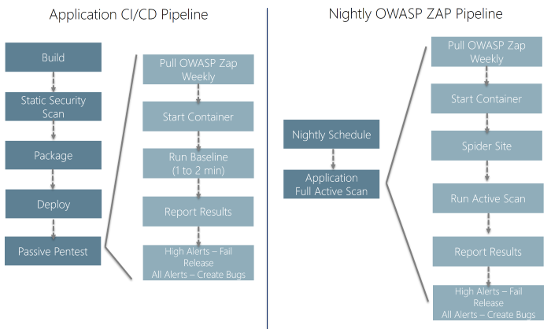

Figure 90 pipelines

In addition to validating the application, the infrastructure should also be validated to check for any vulnerabilities. When using the public cloud such as Azure, deploying the application and shared infrastructure is easy, so it is important to validate that everything has been done securely. Azure includes many tools to help report and prevent these vulnerabilities including Security Center and Azure Policies. Also, we have set up a scanner that can ensure any public endpoints and ports have been added to an allow list or else it will raise an infrastructure issue. This is run as part of the Network pipeline to provide immediate verification, but it also needs to be executed each night to ensure that there aren't any resources publicly exposed that should not be.

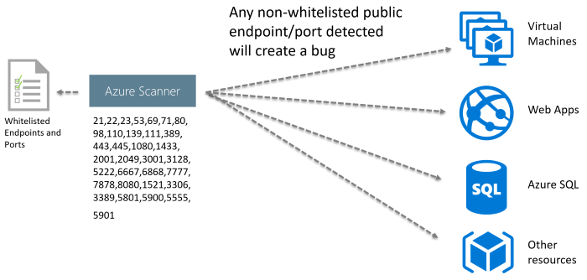

Figure 91 endpoints

Once the scans have completed, the Azure Pipelines release is updated with a report that includes the results and bugs are created in the team's backlog. Resolved bugs will close if the vulnerability has been fixed and move back into in-progress if the vulnerability still exists.

The benefit of using this is that the vulnerabilities are created as bugs that provide actionable work that can be tracked and measured. False positives can be suppressed using OWASP ZAP's context file, so only vulnerabilities that are true vulnerabilities are surfaced.

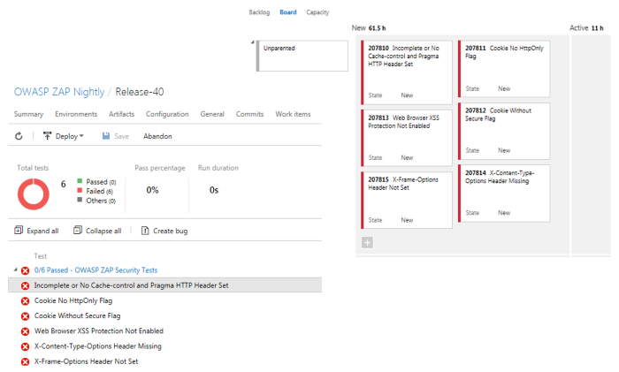

Figure 92 bug workitem

Even with continuous security validation running against every change to help ensure new vulnerabilities are not introduced, hackers are continuously changing their approaches, and new vulnerabilities are being discovered. Good monitoring tools allow you to help detect, prevent, and remediate issues discovered while your application is running in production. Azure provides a number of tools that provide detection, prevention, and alerting using rules such as OWASP Top 10 / modSecurity and now even using machine learning to detect anomalies and unusual behavior to help identify attackers.

Minimize security vulnerabilities by taking a holistic and layered approach to security including secure infrastructure, application architecture, continuous validation, and monitoring. DevSecOps practices enable your entire team to incorporate these security capabilities throughout the entire lifecycle of your application. Establishing continuous security validation into your CI/CD pipeline can allow your application to stay secure while you are improving the deployment frequency to meet needs of your business to stay ahead of the competition.

# Continuous Deployment in Collaboard

Azure pipeline as a core part of Azure DevOps, it allows for the creation of CI ( Continuous Integration) pipeline in a declarative way using YAML documents, it is also called build pipelines. Since last Build 2019, this capability is also extending to CD ( Continuous Delivery ) Pipelines which is also known as Release Pipelines. More than expected is now it is possible to define multi-stage pipelines-as-code for both Continuous Integration and Continuous Delivery with the same YAML definition file.

Since Github can be easily integrated with Azure DevOps nowadays, you can not only build your CI/CD pipeline based on your source code on Github, but also even Mapping your GitHub repository permissions with Azure DevOps.

## Architecture

To provide an end-to-end automation experience to users when deploying CollaBoard client and server via Azure DevOps. Our solution will be look like the following diagram:

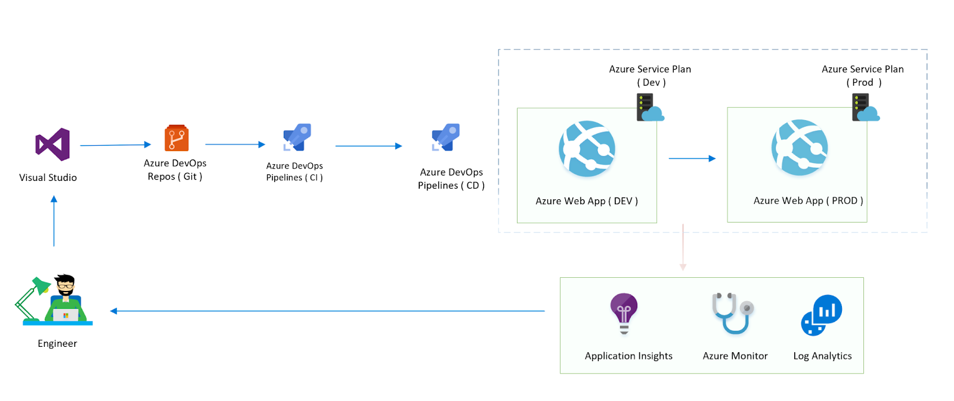

Figure 93 End to End Ci/CD architecture diagram

## Getting started

Before getting started, you have to prepare a couple of things :

Step 1: Get an Azure subscription

You need a Azure account : Create an Azure account by browsing to https://azure.microsoft.com/en-us/free/ or claim your MSDN benefits to get a visual studio subscription.

Step 2: Get an Azure DevOps account and create organisation and project. You can check Quickstart: Create an organization or project collection to know more details.

You’ll need to activate the ‘ multi-stage pipeline’ from the settings of preview feature.

Step 3: Get source from cloudmelon’s Github repository ( using the following URL ), fork it and use your own branch for our lab:

https://github.com/cloudmelon/oss-cicd-devops

## Provision infrastructure via ARM template

One of most important part of end-to-end automation start from automate the infrastructure provision process, by implementing Infrastructure as code (IaC) mindsets, we can use either ARM or Terraform to provision our infrastructure running in Azure.

In this solution, we’re going to provision two App services Plan and host web app on each of them. In enterprise environment, due to budget and performance concerns, usually we deploy Development and Production environment separately. On the top of solution, we can also use full stack monitoring solutions to gain more visibility of Azure resources which we’ll get to later on.

## Define service connections

There are so many discussions around automation and DevOps going on over past a few years. From my point of view, one of the most charming feature of DevOps is you can deploy and automate the whole process as long as you have the right permission. In our example, you only need to replace the service connections then you can get this solution up and running in your subscription. You only need to go to Project settings and add a new service connection as shown in the following :

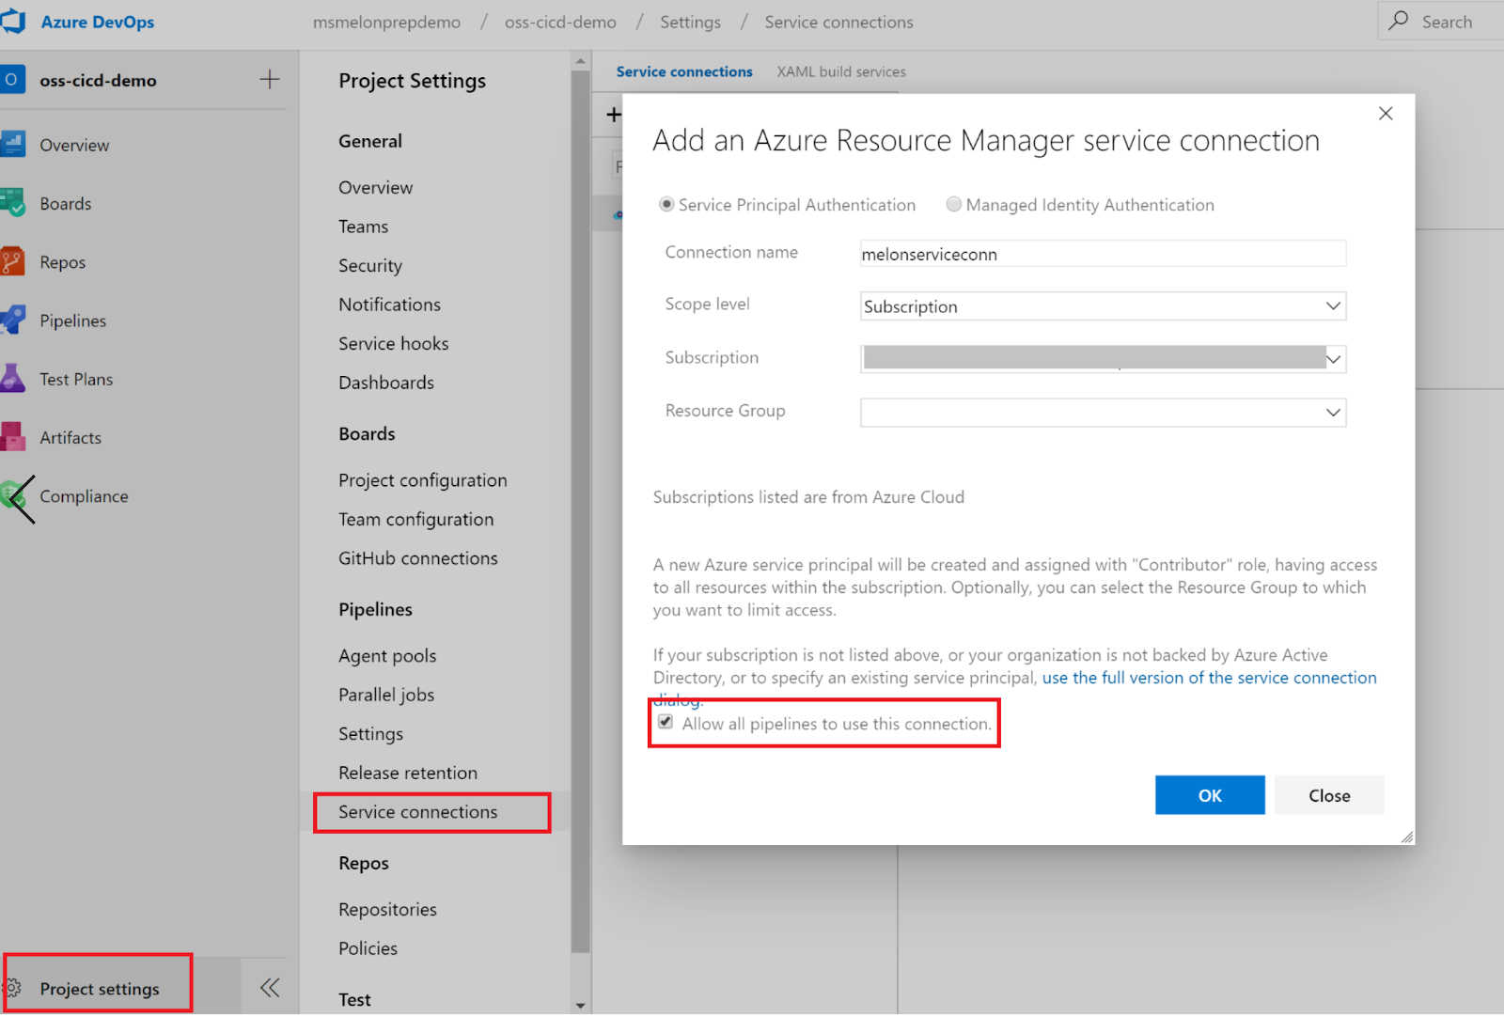

Figure 94 Activate the multi-stage pipelines preview feature

## Trigger and variable definition

Basically, Continuous integration (CI) triggers in Azure DevOps will set off a build to run when a push is made to the specified branches ( by setting path filters ) or a specified tag is pushed. Below is an example of trigger defined in Yaml:

trigger:

- master

In Azure DevOps, you can use variable in Yaml definition or using Variable group and then link up to your CI or CD definition. Below is an example of yaml-defined variables:

variables:

vmImageName: 'ubuntu-latest'

demorg: 'melon-cicd-rg'

subscription: '(please replace it by your own service connection name)'

webappname: 'meloncicdwebapp'

## Define your CI pipeline

In your CI pipeline, you need to define as the following :

stage: Build

displayName: Build stage

jobs:

job: Build

displayName: Build

pool:

vmImage: $(vmImageName)

steps:

task: AzureCLI@1

displayName: 'Azure CLI '

inputs:

azureSubscription: $(subscription)

scriptLocation: inlineScript

inlineScript: 'az group create --location north europe --name $(demure)'

task: AzureResourceGroupDeployment@2

displayName: 'Azure Deployment:Create or Update Resource Group action on $(demorg)'

inputs:

azureSubscription: $(subscription)

resourceGroupName: '$(demurg)'

location: 'North Europe'

templateLocation: 'Linked artifact'

csmFile: 'iac/webapp.json'

csmParametersFile: 'iac/webapp.parameters.json'

deploymentMode: 'Incremental'

task: NodeTool@0

inputs:

versionSpec: '10.x'

displayName: 'Install Node.js'

scripts: |

npm install

npm run build --if-present npm run test --if-present

displayName: 'npm install, build and test'

task: CopyFiles@2

displayName: 'Copy Files to: $(Build.ArtifactStagingDirectory)/$(webappname)'

inputs:

SourceFolder: '$(system.defaultworkingdirectory)'

TargetFolder: '$(Build.ArtifactStagingDirectory)/$(webappname)'

task: ArchiveFiles@2

displayName: '$(webappname) Archive'

inputs:

rootFolderOrFile: '$(Build.ArtifactStagingDirectory)/$(webappname)'

includeRootFolder: false

archiveType: zip

replaceExistingArchive: true

archiveFile: '$(Build.ArtifactStagingDirectory)/$(webappname).zip'

task: PublishPipelineArtifact@0

displayName: 'PublishPipelineArtifact: drop'

inputs:

targetPath: '$(Build.ArtifactStagingDirectory)/$(webappname).zip'

## Define your CD pipeline

Now yaml-defined multi-stage CD pipeline is also supported in Azure DevOps, if you’re not comfortable with yaml definition, you can also check Define your multi-stage continuous deployment (CD) pipeline to know more about multi-stage pipeline.

Please make sure you define different stages, dependencies and deployment condition:

**Dev stage:**

- stage Dev

displayName: Dev stage

dependsOn: Build

condition: succeeded('Build')

jobs:

- deployment: Dev

displayName: Dev

environment: 'development'

pool:

vmImage: $(vmImageName)

strategy:

runOnce:

deploy:

steps:

- task: DownloadPipelineArtifact@1

displayName: 'Download Pipeline Artifact'

inputs:

buildType: 'current'

- task: AzureWebApp@1

inputs:

azureSubscription: '$(subscription)'

appType: 'webApp'

package: '$(System.ArtifactsDirectory)/drop/$(webappname).zip'

customWebConfig: '-Handler iisnode -NodeStartFile index.js -appType node'

deploymentMethod: 'zipDeploy'

**Prod stage:**

- stage: Prod

displayName: Prod stage

dependsOn: Dev

condition: succeeded('Dev')

jobs:

- deployment: Prod

displayName: Prod

environment: 'production'

pool:

vmImage: $(vmImageName)

strategy:

runOnce:

deploy:

steps:

- task: DownloadPipelineArtifact@1

displayName: 'Download Pipeline Artifact'

strategy:

runOnce:

deploy:

steps:

- task: DownloadPipelineArtifact@1

displayName: 'Download Pipeline Artifact'

inputs:

buildType: 'current'

- task: AzureWebApp@1

inputs:

azureSubscription: '$(subscription)'

appType: 'webApp'

appName: '$(prodwebappname)'

package: '$(System.ArtifactsDirectory)/drop/$(webappname).zip'

customWebConfig: '-Handler iisnode -NodeStartFile index.js -appType node'

deploymentMethod: 'zipDeploy'

## Environments

Environment is a new feature of Azure DevOps pipeline, it represents a collection of resources such as namespaces within Kubernetes clusters or Azure Web Apps, basically anything be targeted by deployments from a pipeline. In our example environments include Development and Production environment.

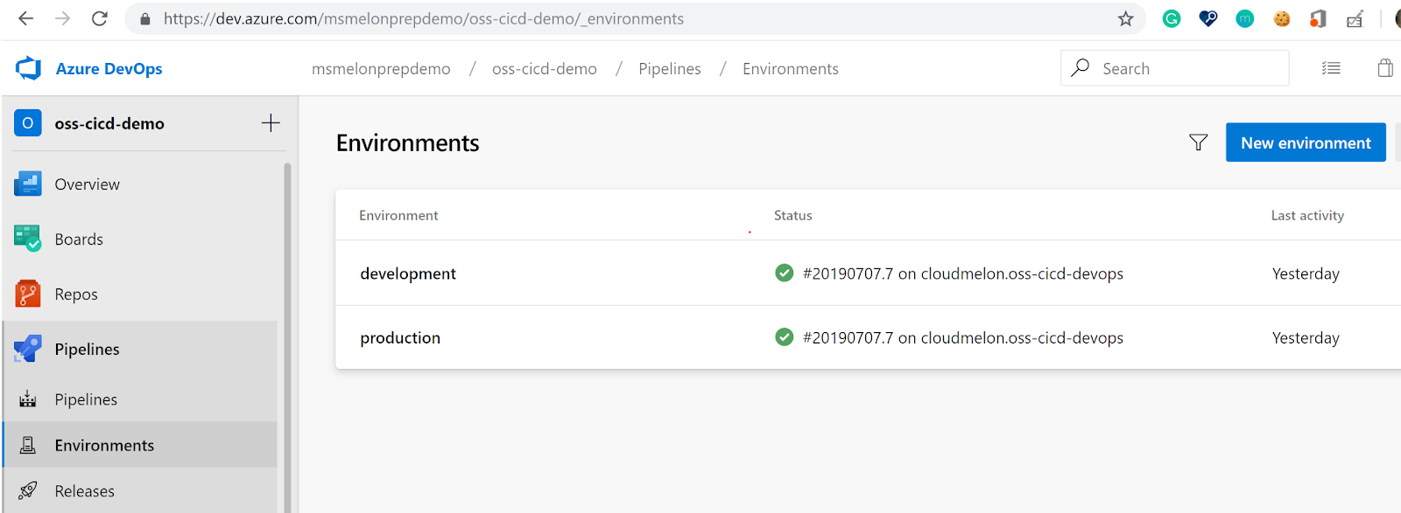

Figure 95 Environments in Azure DevOps

## Azure unified monitoring solution

Since end of 2018, Azure Log Analytics and Azure Application Insights were available as integrated features within Azure Monitor, it is an pretty cool path which shows the possibility to provide administrators and DevOps engineers full stack unified monitoring solution, you can also check End-to-end monitoring solutions in Azure for Apps and Infrastructure to have more details.

Up & Running

You can check your run history and different stages in Azure DevOps

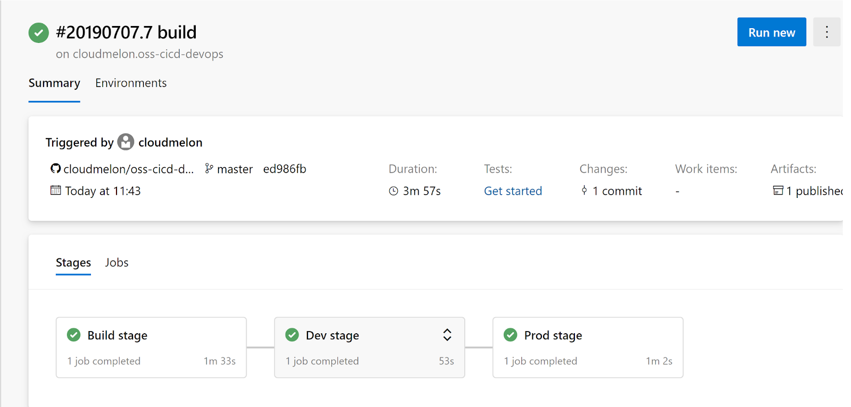

Figure 96 Deploying multi-stage pipelines in Azure DevOps

# Conclusions and next steps

This document covers all the Continuous Deployment process starting from the Continuous Integration pipeline. We started with the Agile processes because it is the corner stone in which the automatic processes (building,

testing, Quality Assurance and deploying) should be built upon.

The journey towards DevOps is extraordinary hard because the first step is the cultural change in order to follow good practices to comply with good quality, testable and robust code. The tools and the infrastructure are worthless if the developers do not use them. So the project and the repositories should provide the methodology, workflows and guidelines in order to correctly use the tools.

That is why along this document we focus not only on the tools to be used, but mainly in how to use them properly. In short, the aim is facilitating the integration process when heterogeneous groups are working together, organizing the work using Agile boards and automating the tedious activities of checking the QA and testing success and coverage. From now on, it is time to learn walking in order to change the workflows accordingly. As we mention many times: communication and adaption.

*“We have two ears and one mouth so that we can listen twice as much as we speak”*

*Epictetus*

# Abbreviations and acronyms

|  |  |
| --- | --- |
| API | Application Programming Interface |
| AR | Assigned Reviewers |
| CA | Consortium Agreement |
| CI | Continuous Integration |
| CD | Continuous Delivery |
| DevOps | Development and Operations |
| DoW | Description of Work |
| IDE | Integrated Development Environment |
| QA | Quality Assurance |
| RE | Restricted to the consortium and other defined groups |
| SCM | Source Code Management |
| TDD | Test Driven Development |
| WIP | Work In Progress |
| WP | Work Package |
| XP | eXtreme Programming |

1. Search Software Quality, http://searchsoftwarequality.techtarget.com/definition/qualityassurance
2. https://en.wikipedia.org/wiki/Resilience_(engineering_and_construction)
3. https://en.wikipedia.org/wiki/Provisioning
4. Search software quality, http://searchsoftwarequality.techtarget.com/definition/continuous-integration